
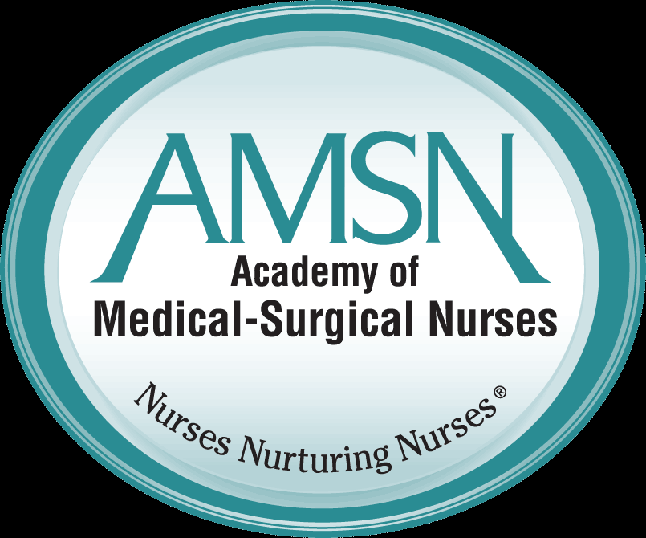


AMSN Local Chapter 111
2015 Convention Scholarship Application
2015 AMSN 24th Annual Convention
September 24-27, 2015
Paris Hotel
Las Vegas, NV

Local AMSN Chapter 111 is proud to offer 2 scholarships to the AMSN National Convention
Go to www.amsn.org for more information on the convention!

Eligibility:
- National Member of AMSN and a member of AMSN local chapter 111 for the year 2015
- Nurse must have at least one year of experience.
- Application must be submitted by June 30, 2015 to be considered eligible.

Details:
- Scholarship recipients will receive $1000 to apply to registration fee and travel expenses.

- Awards are paid after the meeting is attended

- Recipient of the scholarship will be asked to write a small summary of their experience for the local chapter newsletter.

- All applications will be reviewed by Chapter 111 2015 scholarship selection committee.

- All applicants will be notified of the outcome via email

Application: Please include your name and # of years’ nursing experience in your application.

:
This year the local chapter 111 theme is Caring for the Caregiver. In this era of health care reform it becomes more important than ever that we take a moment to care for ourselves and each other spiritually, mentally, and physically. Please focus your essay on that theme.

Application must be typed in a word document.
You may e-mail the documents to Sheila Farina @ farinasm2@upmc.edu

All essays will be blind reviewed, i.e. the names of the candidates will not be available to the reviewers.

Applications will be reviewed based on the following criteria:

- Rubric: 35 point total

- 5 pts for formatting (grammar, spelling, etc.)

- 10 points for each bullet point below
-.
- Describe the need for med surg nurses to care for themselves and their colleagues

- Describe the relationship between a “cared for nurse” and her ability to provide an exceptional patient experience

- Describe how you care for yourself or care for your colleagues

All applications must be received by June 30, 2015

Thank you and good luck!

