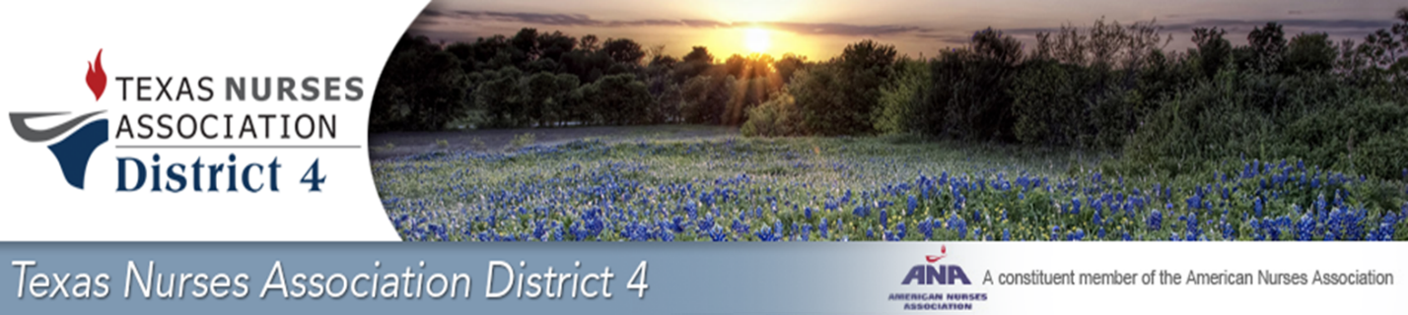

**2025 Nomination Ballot TNA D4**

**Name:**

**Email:**

**Phone:**

**Member of TNA: Yes or No**

**If no when will you plan to become a member?**

**Please attach your Nomination Application, Resume, Bio with Picture, and any information you like to share (certifications, committee work, previous positions held) and email to** [**TNA4.LSC@gmail.com**](mailto:TNA4.LSC@gmail.com)

**Circle or Highlight what positions you are interested in:**

* 1. President-Elect
  2. Secretary (1)
  3. Board Positions (3)
  4. Leadership Succession Committee (3-5)

**Email Application, Resume, Bio with Picture back to the Nomination Chair by April 27, 2025**

Robin Hunter MSN, RN

District 4- Chair Leadership Succession Committee

[**Email: TNA4.LSC@gmail.com**](mailto:Email:%20TNA4.LSC@gmail.com)