Meeting Monday April 28, 2025
Dinner and CEU Presentation
Sponsored by Medtronic, Josh Lancaster
“Surgical Smoke”
5:30- 6:00 PM Meet and Greet
6:00-8:00 PM Dinner and Presentation
Owen Brennan’s
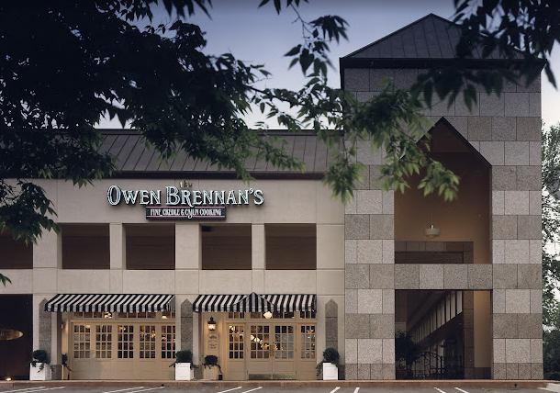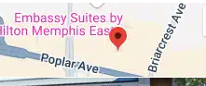
RSVP: Karen Elliott kpelliott12@outlook.com or 901-490-6579 kaelliott@regionalonehealth.org
Save the Date : May 19, 2025 Memphis AORN Meeting: “All you wanted to know about suture but were afraid to ask”
July 15, 2025 Stryker Moblie Experience Lab

