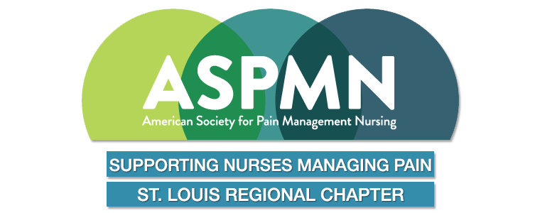

Chapter Newsletter

Volume 25 Issue 1 2025

1 Word from the President

2 CNE opportunities / National Conference Info

3 Research Grant / Pain Nurse of the Year / Meeting Dates 2025 / Board Members
The mission of the American Society for Pain Management Nursing St. Louis Regional Chapter is to support integrative, whole person, evidence-based care to all those experiencing pain. This shall be accomplished through collaborative and inter-professional partnerships, education, research and advocacy.

Word from the President…
Feeling the energy of the New Year, the Lunar Eclipse happenings and welcome Sunshine in March! Networking with colleagues at the ASPMN Chapter Support Group Meeting brings our chapter new ideas and resources. Our chapter sponsored two board members to attend National Conference in 2024 and they have both worked hard to bring ideas back for education for our local colleagues. We look forward to offering three virtual FREE CNE opportunities in 2025. Also planned is an opportunity for networking - a Meet and Mingle later this year, details as soon as available.
Our Chapter Board of Directors continue to participate not only a national level, but at a local level. I am hopeful you will join us at our next local offering for an evening of education. I cannot express my appreciation enough to our Chapter Board of Directors for their continued tireless work, guidance and support.
Thank you.
Jean Brontoli BSN, RN

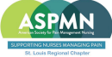

CE Opportunities in our Area, OnLine and National Conference Information
Advanced Pain Pharmacology Webinar March 13 – April 3, 2025
Register for sessions you are interested in attending: choose 1, 2, 3 or all https://members.aspmn.org/slideshows/click.php?id=37489

St. Louis Regional ASPMN offering:
April 9, 2025 Time: 6pm via Zoom
Family Dysfunction, Trauma, Pain and Substance Use Disorder in Childbearing-Aged Females.
Jamie Morton PhD., RN
FREE Virtual CNE Education
Zoom Meeting Link



Information on National Conference and Continuing Education Available on ASPMN Website
https://aspmn.org/

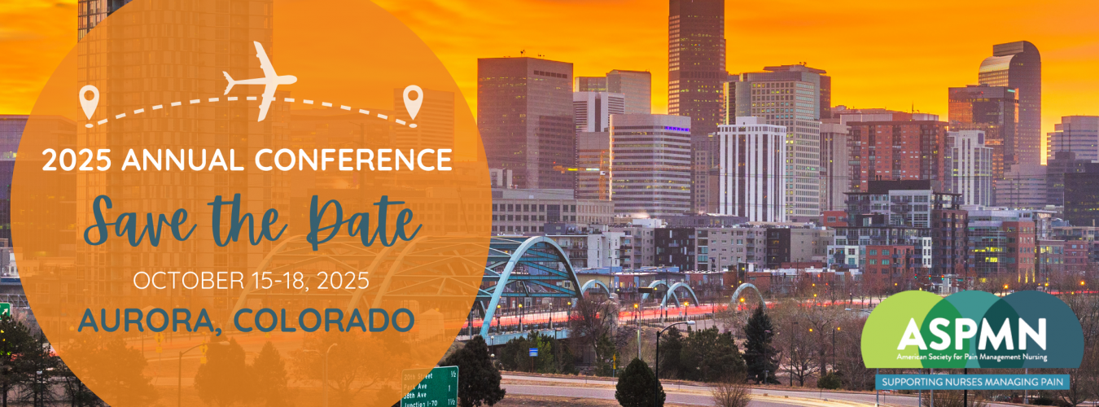

St. Louis ASPMN Research Grant – available on website

Pain Nurse of the Year Award- available on website

ASPMN MANTRA:
Every nurse is a pain care nurse. It’s imperative to stay up to date on cutting edge pain management techniques, therapies, and industry advancements.

2025 Business Virtual Meeting Dates:
Mark your calendars & we’ll post More Information on the Website as available:
January 29, 2025
April 29, 2025
August 20, 2025
November 5, 2025
Link available by email

CHAPTER NEWS:
REMEMBER THAT STL CHAPTER MEMBERSHIP IS FREE TO EVERYONE!! HOWEVER, YOU NEED TO RENEW YOUR CHAPTER MEMBERSHIP ONLINE AND YOU NEED TO BE A MEMBER OF THE NATIONAL ORGANIZATION TO BE ELIGIBLE FOR THIS ONE YEAR FREE STL MEMBERSHIP. PLEASE ENCOURAGE ALL NURSES TO JOIN!!

St. Louis Regional ASPMN Board Members 2025:
President – Jean Brontoli
( jbrontoli@gmail.com)
Past President –
President Elect – Open Position
Secretary currently rotating - Open Position
Treasurer - Linda Feinberg
(dunajciklm@aol.com)
Program Chair & Past President - Gail Hurt
(gail1202hurt@gmail.com)
Nominations - Ann Bearden
(anncolbear@aol.com)

