|  |  |  |  |  |
| --- | --- | --- | --- | --- |
| **AORN RNSA** | | **Quarter 1** | **Jan – Mar 2025** | |
|  | **Retired Nurses Special Assembly Newsletter**  **By and for AORN nurses** | | |  |
|  | | | | |

Please note our group name. We are made up of retired nurses but also include those of you that are taking a break from work for various reasons. As older retired nurses, we offer ourselves as educators, sharers of our years of knowledge and experience. All we need is for someone to ASK, and you will be surprised at what you learn.



[This Photo](https://creoleindc.typepad.com/rantings_of_a_creole_prin/2008/08/from-sip-note.html) by Unknown Author is licensed under [CC BY-NC-ND](https://creativecommons.org/licenses/by-nc-nd/3.0/)

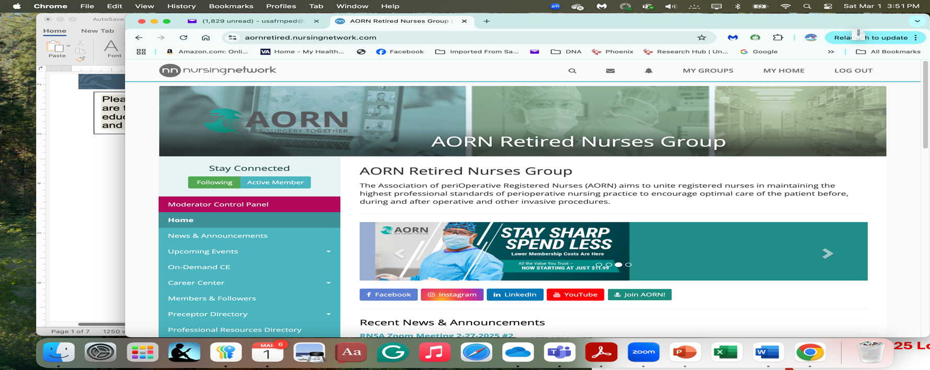

[www.nursingnetwork.com](http://www.nursingnetwork.com)

<https://aornretired.nursingnetwork.com/>

This is our new home page. If you have not signed into AORN main page, you will probably need to do that to access the nursing network site, which will require another sign-in. Once you have found a group, you have dropdowns on the left that you can explore. Announcements for upcoming meetings or events may be on the front page for the group. Check out the space and explore. Let us know if you have any questions. We’ll help!! A screenshot of our page is included for reference. You can enlarge by clicking on the picture and go from there.

Second Newsflash. Rather long but important.

**ANA undergoes logo changes/rebranding**

Evolution of our Older logos

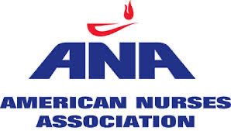 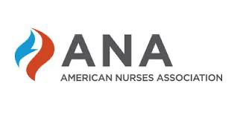

**New 2025 Logo**



<https://www.nursingworld.org/news/news-releases/2024/american-nurses-enterprise-unveils-new-brand-identity-at-the-ancc-national-magnet-conference-and-pathway-to-excellence-conference-in-new-orleans/>

American Nurses Enterprise Unveils New Brand Identity at the ANCC National Magnet Conference® and Pathway to Excellence Conference® in New Orleans

**Nov 1st 2024**

**MEDIA CONTACT**: Keziah Proctor [keziah.proctor@ana.org](mailto:keziah.proctor@ana.org)

***THE POWER OF NURSES Takes Center Stage at Annual Fall Conferences***

**(November 1, 2024, SILVER SPRING, MD)** – Today the [American Nurses Enterprise](https://www.nursingworld.org/ana-enterprise/) announced that its family of brands – the [American Nurses Association](https://www.nursingworld.org/ana/) (ANA), the [American Nurses Credentialing Center](https://www.nursingworld.org/ancc/) (ANCC), and the [American Nurses Foundation](https://www.nursingworld.org/foundation/) (ANF) – is undergoing a comprehensive rebrand after more than 125 years of excellence in service to the nursing profession. The new brand was revealed during a high energy, dynamic presentation celebrating **The Power of Nurses™** and the value of the profession during the annual ANCC National Magnet® and Pathway to Excellence® Conferences in New Orleans, Louisiana.

Through this brand refresh, the American Nurses Enterprise will expand its reach beyond traditional audiences to become recognized by the global healthcare community and the general public as a trusted leader in healthcare. The rebrand was accomplished in close collaboration with stakeholders and affiliated constituent and state nurses associations, to ensure alignment, unification, and amplification of the American Nurses Enterprises' work throughout the country and around the world. The focus of the new brand is centered on "The Power of Nurses," which is both a truth and a call to action.

When nurses connect with the American Nurses Enterprise family of brands, their power is multiplied, creating a united force that drives lasting impact across healthcare. With that in mind, the American Nurses Enterprise is doubling down on its vision and mission and introducing an evolved value proposition to better serve the needs of both nurses and patients while staying concurrent with a rapidly changing, dynamic healthcare landscape:

**American Nurses Association**. Championing nurses as the heartbeat of healthcare, ANA works to ensure nurses get the recognition and support they deserve. This is accomplished by providing a sense of community and deep connections, practice standards and policy development, professional ethics guidelines, advocacy and influence on legislative and regulatory policy, professional development and continuing education opportunities, and well-being resources.

**American Nurses Credentialing Center**. Advancing the highest standards of nursing excellence is the clarion call of ANCC. It routinely works with some of the largest and best healthcare organizations and systems around the world to set rigorous standards of nursing practice and conduct research to drive safer patient outcomes. This is realized through organizational credentialing, individual credentialing, accreditation, and nursing research and quality.

**American Nurses Foundation**. Inspiring transformational change is what leads ANF. Through philanthropy and strategic partnerships, it empowers nurses to create change for entire healthcare systems and communities by mobilizing resources, leading groundbreaking research, and fielding innovative pilot studies.

"I am excited to announce that our organization is amidst a powerful, transformational journey. While we draw from more than 125 years of advocating and working tirelessly to advance the profession of nursing, we have an unwavering focus on the future," said American Nurses Enterprise CEO Angela Beddoe. "As an organization, we are driven by our collective vision and mission, which beckons us to elevate the work nurses do and the value they bring to healthcare delivery while providing meaningful support, opportunities, and guidance. Nurses are the heart and soul of this ever-progressing brand. That's why we are deliberate in aligning each organization within the Enterprise family to meet the needs of nurses and advance the profession. As the leading voice of the nursing profession, it's important for us to show the world that we are united under a common goal, and we are one – through The Power of Nurses."

The time for transformation is always. Please watch the new brand anthem video, "Nurses Symphony" to view the new American Nurses Enterprise brand and to witness the Power of Nurses: <https://youtu.be/2UVOUkCwDLY>

***About American Nurses Enterprise***  
*American Nurses Enterprise unites the expertise and dedication of the American Nurses Association, American Nurses Credentialing Center, and American Nurses Foundation to champion nurses, advance standards of excellence and inspire transformative change. With a powerful legacy and forward-thinking vision, our influence spans federal and local levels working through state affiliates and partners to amplify the voice of nurses across all practices and specialties. Every day, we harness****The Power of Nurses™****to increase the value of the nursing profession and transform the healthcare experience for all.*

***About American Nurses Association***  
*The American Nurses Association is the only association that represents and serves as the professional home for all registered nurses in every specialty and practice setting. We believe nurses are the heartbeat of healthcare. It is our calling to champion nurses and the causes they care about by working for improved work environments, top-notch education, smarter policies, and stronger partnerships. We advocate to amplify nurses' roles, their voices, and their value across healthcare and in society.*

***About American Nurses Foundation***  
*The American Nurses Foundation inspires transformative change by mobilizing resources to deliver solutions that matter. Through intentional partnerships and impactful philanthropy, we strive for intentional investments to meet the specific needs of nurses and to remove barriers to research funding for nurses of all backgrounds. We empower nurses to create change from the inside out, not only for themselves, but for all healthcare systems and communities.*

***About American Nurses Credentialing Center***  
*The American Nurses Credentialing Center works with the largest group of healthcare professionals and their organizations to advance the highest standards of nursing excellence. Nursing is an art and a science that requires opportunities for growth, development, research, and innovation. We believe that having an impact on the level of care provided requires setting rigorous standards and conducting research that not only ensures the well-being of nurses, but also drives safer patient outcomes worldwide.*

*Member Spotlight*

Cheryl Sumner, RN, CNOR-(E)

[clsumner@yahoo.com](mailto:clsumner@yahoo.com)

I was asked by our newsletter publisher, Dr. Pamayla Darbyshire for our Retired Nurses Special Assembly to tell everyone a little about myself. I have forty-five years of nursing under my belt. I became an RN in 1974. At that time, nurses were still required to wear a white ironed uniform, white hose, hair pulled back, white polished shoes, and a white starched cap. The hem of our uniform was not allowed to rest above our knees, or you would be sent home.

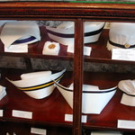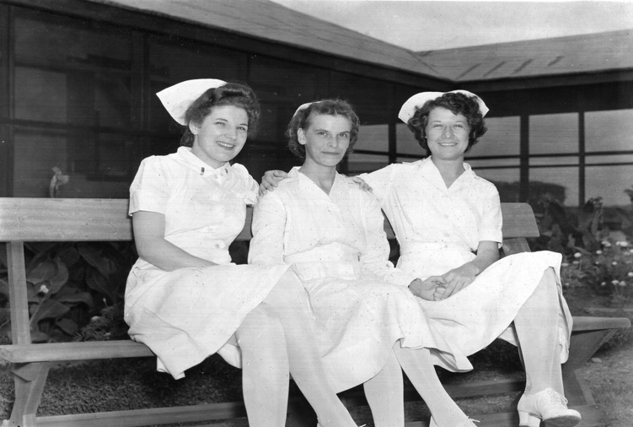

I lived in southwestern Pennsylvania just south of Pittsburgh. I started out working on a “post coronary care / surgical floor.”. At that time, there were no monitors. A “Code” event was usually discovered during our frequent nursing rounds, and you needed to rely on your co-workers for assistance. One of my favorite co-workers would argue with me over whose turn it was to do the “mouth” while the other did the chest compressions. We did a damn good job.

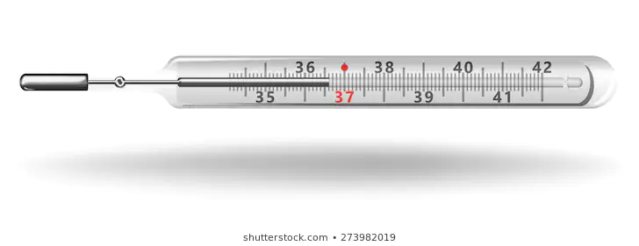

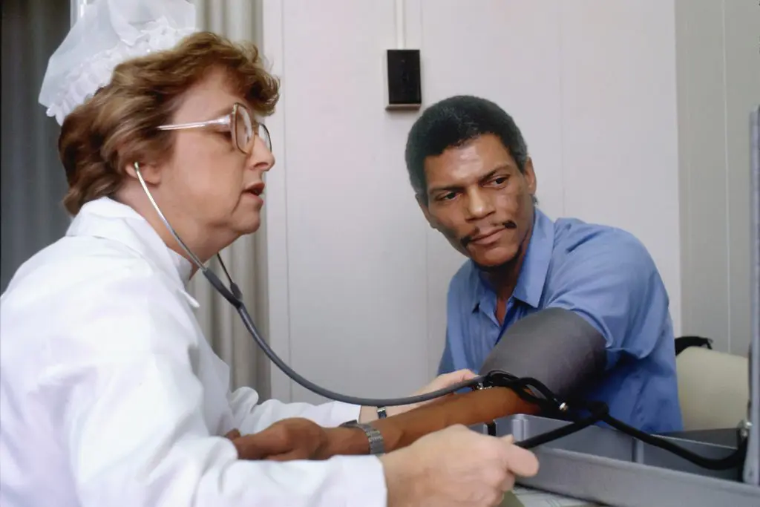

We passed out food trays, fed those who needed assistance, manually shook down mercury thermometers before taking temperatures (and had trouble reading the results on those tiny numbers), manually took BP and pulses, and assisted patients to the bathroom (things CNAs do today). We also charted on each and every one of our patients in blue, green, or red ink, depending on your shift. We were of the era when a doctor came into the nurses’ station; you would immediately stand up, giving them your seat, grab their charts, and make rounds with them (of course, you carried all the charts). There were always 2-4 patients to a room, and we only had 3 private rooms for VIPS. Talk about HIPAA violations! I loved that job, and I learned something new every day. I really enjoyed my patients and my fellow coworkers. We practiced the team approach of nursing to care for our patients. Everyone knew what job they needed to do; everyone helped each other to ‘getter’ done.

But…. I felt like something was missing. Every time I transported a floor patient to the OR, I lingered to see what was going on behind the closed doors.

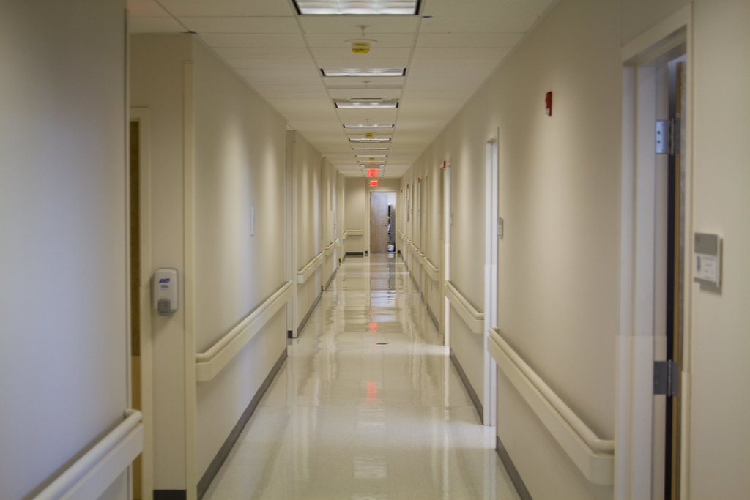

By the way, I did do a surgical rotation in the OR during nursing school (one day) and I was completely fascinated. So, within the year, I put in for a transfer to the OR. It took a while but finally in January of 1975. My transfer was approved!! Down to the OR I went. It was such a new and different environment, and I loved it. I made mistakes, but I learned from each and every one of them. The staff were very good to me, and I knew I had found my place. I was extremely busy learning new information, from instruments and their uses to the different surgeries. We did everything in our little six OR suite except open hearts and neuro. We were assigned to different specialties every four months, learning and keeping current with new changes in technology.

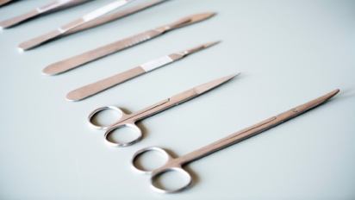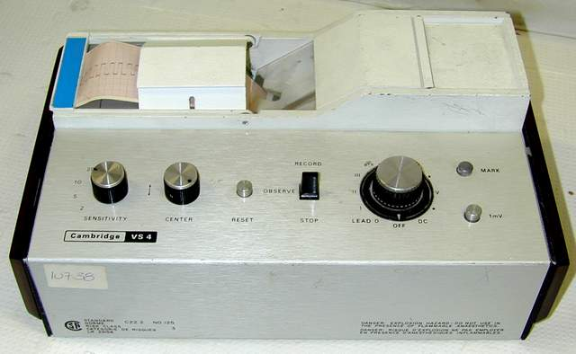

In September of 1975, I married the love of my life. This year (2025) will mark 50 years that we have been together. He is my rock. (Congratulations from RNSIG). I have two daughters: one was born in 1977 and the other in 1979. They keep me on my toes.

In 1983, I took the CNOR exam and passed. I was a very proud lady. (Great honor, congrats again).

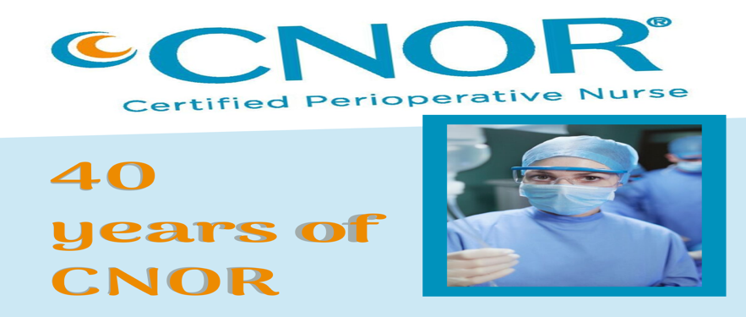

In 1986, my husband accepted a position in Columbus, Ohio. We moved from SW Pennsylvania to Columbus in November and believe me when I say I went kicking and screaming. I loved my job. We uprooted our daughters, and we left to face the unknown. It was very tough on all of us, but looking back, it was the best decision. I waited to start a job, making sure I got our daughters settled. In February 1987, after exploring my options, I decided to accept a position at The Ohio State Medical Center in the OR. Remember, I started out in a 6-room OR and going to a 26-room OR was overwhelming, but I had great co-workers who helped me manage and get through it all. I thoroughly enjoyed Transplants, but on-call was extremely tough. My drive to work was over 45 minutes; my husband frequently worked out of town, and I needed to look for something closer to home. I started work in a smaller hospital closer to home.

All was well until the HR department at Ohio State called to let me know I was 20 days short of being vested. This was during the nursing shortage crisis. So back I went to OSU. This time I worked at The James Cancer Hospital. So sad but yet so rewarding. I worked there until January 2000, when my husband was transferred to Atlanta, GA. I took a travel assignment to figure out the lay of the land, and I worked at Southern Regional Medical Center. Then, back to Columbus, Ohio, within six months due to a job transfer for my husband. I worked there for another nineteen years.

In 2017, Expo was held in Boston, and I decided to go. I discovered the Retired Nurse Special Assembly. Since I was very close to retiring, I was curious to see what this meeting would include. I met Melanie Burton, who was presenting the educational CEU’s and JoAnne Balthazar, who was the current Chair of the Retired Nurses Special Assembly. They both asked me if I would be willing to serve as the chair-elect. I agreed since I would be retiring in two years. I have been involved ever since.

**EDUCATIONAL EVENTS**

Hi All,

I am pleased to announce this upcoming event at AORN Expo in Boston, April 5, 2025, at 2:45 p.m. during the Executive Summit. If you cannot attend, I have applied for a CE that we can use for our specialty assembly at some time later. The title is “A Tapestry for Sustaining Perioperative Excellence.” It is an in-depth look at roles we can play to expand our involvement and help reduce the nursing shortage.

**Joanne Oliver-Coleman**

**MBA-HM, BSN, RN, CNOR(E)**

Perioperative Nurse Entrepreneur

DBA Healthcare Resources

joliver@hcresources.net

281-444-7407

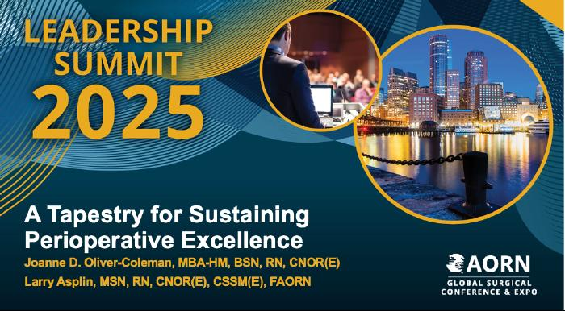

**Food for thought**

Pat Moody diet . . .who didn’t gain a pound while on a cruise (do I have the right person?)

State News

Most state Boards of Nursing have links for CEU’s. Each state has certain mandatory units for license renewals; be sure to check your BON for updates to renewal requirements. AND a gentle reminder: don’t wait till 30 days or so to start the renewal process. It just could take longer with any issues to complete.

**Last thoughts:**

The RNSA newsletter is published quarterly at this time. Comments and/or RNSA Newsletter materials, suggestions, etc., are welcome and may be sent to:

Pamayla Darbyshire [usafrnped@yahoo.com](mailto:usafrnped@yahoo.com)

**Thank you to all contributors.**

**RNSA Council:**

Chair: Cheryl Sumner, RN, CNOR (e) (OH)

Past Chair: Cathy Ostroski, DNP, RN, CENP (NJ)

Chair-Elect: Cheryl Sumner, RN, CNOR (e) (OH)

RNSA Mentor: Joanne D. Oliver-Coleman, MBA-HM, BSN, RN, CNOR (e) (TX)

Board Liaison: Tracey Peñaloza, MSN, RN, CNOR (MD)

Communications Chair: Patricia Moody, RN, CNOR (e) (IN)

Communications Chair-Elect: Patricia Moody, RN, CNOR (e) (IN)

Education Chair: Melanie Burton, BSN, RN, CNOR, MLSO (WA)

Education Chair-Elect: Melanie Burton, BSN, RN, CNOR, MLSO (WA)

Newsletter: Pamayla E. Darbyshire, DHA, MSN/CNS