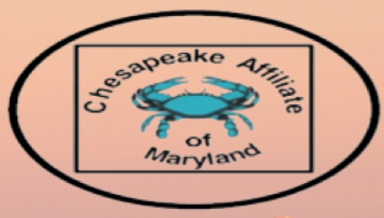
March 7 , 2025 Chesapeake Affiliate of Maryland Member Meeting Agenda
- Welcome, Introductions, announcements
- Treasurer Report
- Overview of 2025 Meeting Schedule, including date and location of in person meeting
- Call for nomination of new officer candidates
  - Timeline
  - Duties & Responsibilities
  - Nominating Committee

- Recruitment Flyer
- Needs assessment 2025
- NPD Certification
- Professional Development Opportunity for members – ANPD recorded webinar – CE available.

