2025 Vaccines for Children (VFC) and Vaccines for Adults (VFA) Annual Enrollment Checklist
2025 VFC/VFA Enrollment Tasks
Completed VFC Enrollment Survey. Please print a copy for your records.
Completed VFA Enrollment Survey. Please print a copy of your records.

Medical Director signed final page of both enrollment surveys and returned to ND HHS Immunization Unit via email to vaccine@nd.gov.

Primary and secondary contacts completed VFC Educational Module.

Primary and secondary contacts completed required post-test.

Double check expiration dates on all data loggers and back-up data loggers. Providers are responsible for purchasing their own data loggers.

Review your facility’s Vaccine Management Plan to make sure it is up to date. Plans must be signed and dated each calendar year or more frequently as information changes. Templates can be found on the ND HHS Immunization Unit’s Resource Page.

If all boxes are checked, your facility has completed the 2025 enrollment process.

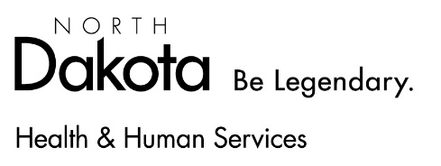
Updated 2/2025

