

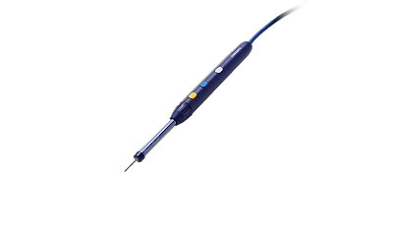



Event Sponsored By:

**AORN Maine Chapter Social**

**at Davinci’s Italian Eatery**

**150 Mill St. Lewiston, ME**

**Thursday March, 27th 2025**

**5:00 – 8:00 p.m.**

Come and learn about the updated Stryker electrosurgical lighted pencil while enjoying delicious appetizers sponsored by Stryker.

Please RSVP to aornofmaine@gmail.com by March 21st

AORN of MAINE



CHAPTER 2001