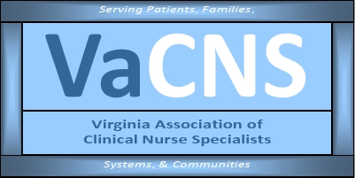

**Our Mission:**

**Promote the role of the clinical nurse specialist as an advanced practice registered nurse in Virginia, and improve systems of care, prevent disease, and enhance health   
and well-being through evidence-based care of populations.**

**MEMBERSHIP MEETING AGENDA**

February 10, 2025

5:00 pm to 6:00 pm

Zoom Meeting:

<https://us02web.zoom.us/j/611829893?pwd=Tkl1aWJOY0JhelVkMUlUaFpkK0MrZz09>

Phone number 1-929-205-6099; Meeting ID: 611 829 893 Passcode: 329587

|  |  |
| --- | --- |
| **Discussion Items** | **Facilitator** |
| **Welcome & Announcements**   * Introductions * Member achievements * NACNS Updates/conference volunteers * Committee chair openings | Jen / Members |
| **Minutes**  • Approval of minutes | Ellen Harvey |
| **Reports**  • Treasurer  • Social Media  • Standing Committees   * Finance * Program Planning * Growth & Succession * Legislative/Regulatory * Open discussion | Holly Tenaglia  Amy Lucas  Cathy Smith  Shelly Milburn/Lauren Turner  Cindy Ward  Sarah Taylor / Becky Bowers-Lanier  Group |
| **Next membership meeting:** | March 10, 2025, 5:00 pm ? |