MP00234_ Association of Rehabilitation Nurses

Southeast Texas Chapter

SETX ARN

***PRESENTS***

**A CLINICAL DISCUSSION ON INTRATHECAL BACLOFEN THERAPY BEST PRACTICES**

**Guest Speaker:**

**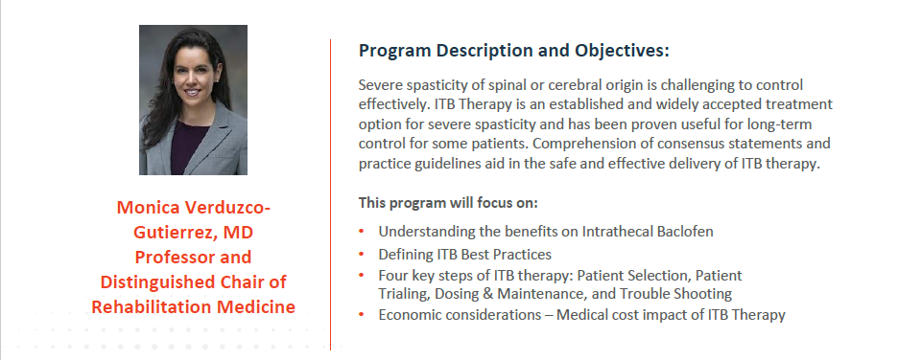**

## Tuesday – January 28, 2025

**Check in: 5:30**

**Speaker/Dinner: 6:00 – 7:00 PM**

***Meeting Location:***

**Fleming’s Prime Steakhouse**

**788 W Sam Houston Pwy N**

**Houston, TX 77024**

**RSVP required at ARN website**

[https://arnsoutheasttx.nursingnetwork.com/](https://urldefense.proofpoint.com/v2/url?u=https-3A__arnsoutheasttx.nursingnetwork.com_&d=DQMFaQ&c=cBOA5YEoZuz9KdLvh38YxdrPtfJt83ckXekfBgq5xB0&r=Wv32iU_WtOf2TI9DAz8LPoRqjQvg1bcpJJQCnHUF9Fj2EROsDcCbR-qgPR9xD6br&m=V9mixdal7h84vKckBr0gPvAbkXep9RtbLWz-efks1J8&s=EQ_2GGn3rzEO2L67s_vlVoNeXD2Fzpk-Dyz023cuyAE&e=)

***Maximum # of attendees: 35***

**STRICT RSVP Deadline: *Wednesday, January 24 at 4:00 P.M.***

**IMPORTANT: You will receive a message to register on Piramal website to complete registration for attendance**

This event is free of charge for SETX Chapter ARN Members

***This activity DOES NOT provide contact hour***

**Southeast Texas ARN gratefully acknowledges the support of Ashley Clapp, Piramal Texas Territory Manager for Intrathecal Therapies for hosting this event.**