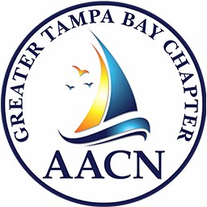 **Save the Date!**

**Greater Tampa Bay Chapter of the American Association of Critical Care Nurses**

Proudly Presents:

***TIDES OF TAMPA BAY***

**Saturday February 22, 2025**

8:00am – 1:15pm

***AGENDA:***

***8:15-9:15 am*** *-* Speaker 1: **Dr. Abhi Patil, Board Certified Gastroenterologist *– Managing Upper GI Bleeding***

***9:15-10:15 am*** - Speaker 2:**Sandy Salicco, MSN, RN, Alumnus CCRN *– Helpful Tips to Prevent Failure to Rescue***

***Break / Exhibitors***

***11am-12noon*** - Speaker 3:**Kimberly Atrubin, MPH, CIC, CPHQ, FAPIC *– What Critical Care Nurses Need to Know About Infection Prevention***

***12noon-1pm*** - Speaker 4:**Dr. Betty Holt, DNP, MSN, APRN *– The Psychological Impact on Critical Care Nurses Caring for Mentally Ill Patients***

***1-1:15pm*** - Closure:**Certificates and Final Drawings**

Information/ Registration is posted on our website: *aacntampa.nursingnetwork.com*



***\*Please note that due to circumstances beyond the Chapter’s control, speakers and/ or agenda may change!***

***Please dress in layers as rooms may be cool / warm at times, and often difficult to control for everyone!***