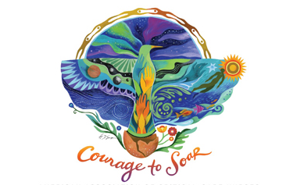

**January Educational Dinner & Board Meeting**

**Sponsored by:**

*Smith & Nephew*

Topic: Pressure Injuries

Speaker: Sarah Borowski

**Tuesday, January 21st, 2025**

***6pm - 7:30pm***

Maggiano’s in DTC

7401 South Clinton Street

Englewood, CO 80112

We are still collecting donations for the Colorado Coalition for the Homeless! Please consider donating new or gently used winter clothes, coats, socks, boots and/or snacks (no nuts or hard candies)!

See more information and register for the event on Nursing Network. A limited number of seats are available.

