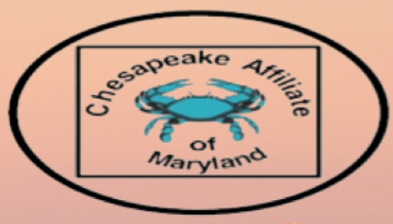
Jan 10, 2025 Chesapeake Affiliate of Maryland Member Meeting Agenda
- Welcome & Introductions
- Treasurer Report
- Overview of 2025 Meeting Schedule & Location
- Call for nomination of new officer candidates
  - Timeline
  - Duties & Responsibilities
  - Nominating Committee

- Suggestions for additional committees
- Needs assessment 2025

