DATE: September 7, 2024 LOCATION: Banner Heart Hospital @ 1000 In Person and Virtual
Agenda / Issues | Discussion – Actions – Recommendations | Presenter
Welcome, Call to Order | Welcome at 1013.  Vendor at the end of the meeting.  Education provided by Bill Adams of SureCount “How Innovations in Surgical Instrument Management Devices Can Improve the Patient, Staff and Fiscal Safety of Your Healthcare System”  Lunch was provided by SureCount | Caryn
Announcements | .  - Treasurer’s Report- 7/1 – 6/30 is the year  16 people registered for the fall conference so far.  Uncertain how many members we currently have. Many people have not updated their address. Please make sure Periop 101 people need to put into their home address so they get the benefits of announcements and magazine.  Need to not have more than $50K in our account due to 403 nonprofit status.  Questions inquired about investing savings to create income, Patricia will inquire with AORN. Money could be used to send more people to EXPO.  Considering doing a CNOR Prep Course in the Spring.  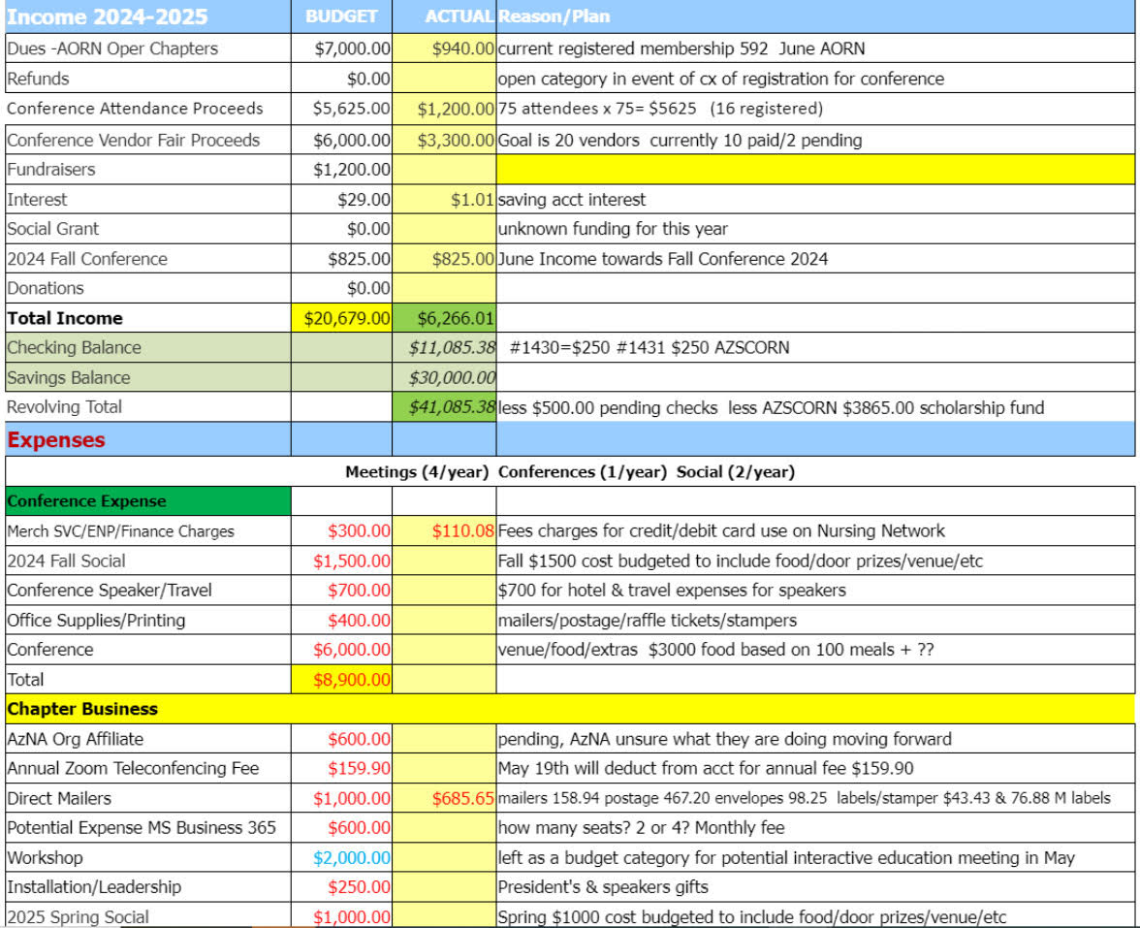  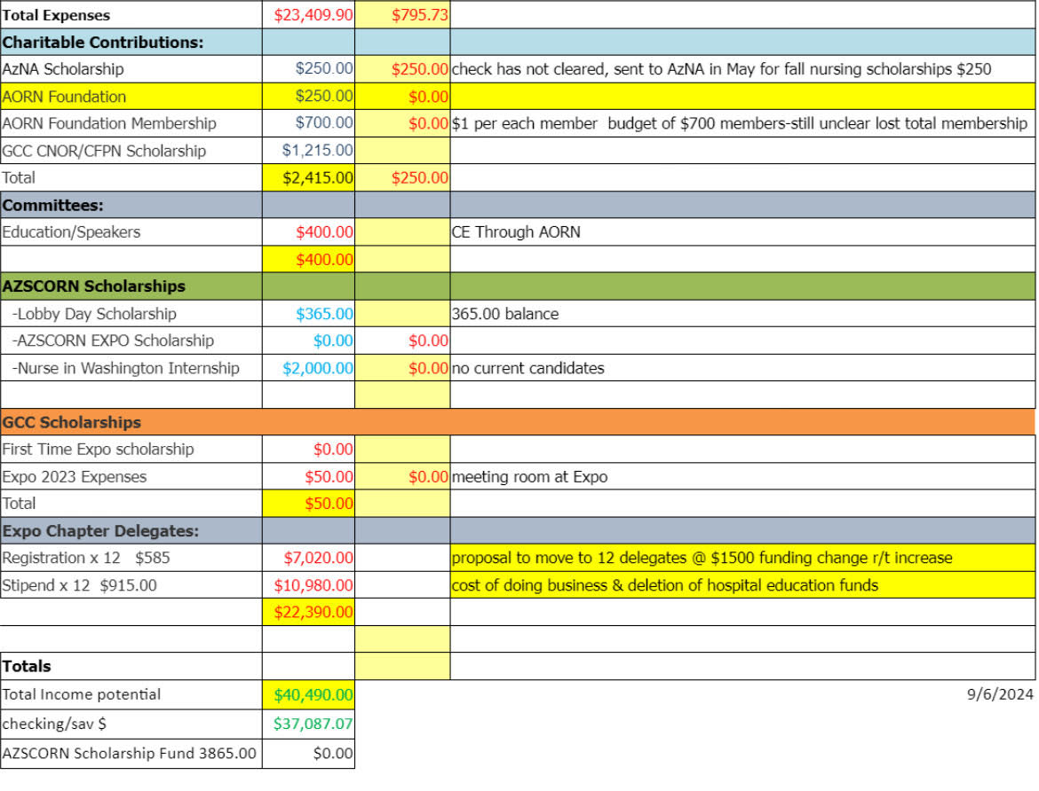  - Legislative Report – Patricia Coates and Dan Wade  3rd Monday of every Month call for the whole state. Patricia Coates is the state chair. Dan Wade is also involved with this call as well.  Funding is available from National Institute of Health. Legislative decisions are being made by non-healthcare individuals. Getting involved helps with being able to make changes.  RN Circulator Bill is being brought forward with Rep Selina Bliss on 9/11/24.  RN Circulator- Each Patient- Every Time  Some surgery centers are having one RN managing more than one room.  Dr Shah has helped facilitate the smoke evacuation bill. Dr Shah is running for a National position. Dan Wade is having a meet and greet to support him and create awareness regarding the topics that affect nursing. (6 bills for nursing)  Caryn Huffman-  - Fall Conference is October 26, 2024. Early Bird does close on Oct. 1, 2024. Approx 14 vendors registered as well.  - Volunteer Opportunities January 18, 2025 – Project Cure- must sign a waiver. (posted on Nursing Network and Facebook group page)  Planning to find more opportunities as well.  - Delegates for EXPO and forms available for anyone interested. Will be needing additional board members next year.  President Elect  Treasurer  Committee Members x2  Nominating Committee x2  - New Business- Open Discussion-Patricia Coates planning to do a mission trip to Africa and looking for 3-4 more people. May 1-8, 2025 and the May 8-16, 2025. Patricia does her own fundraising to help support pay for the trip.  Jackie Craig- Anyone having difficulty instituting the smoke evacuation policy. Tenet Hospital Center staff are unfamiliar. Reporting 1-800-985-3059 is where complaints can be submitted for hospitals in AZ not compliant.  Grateful to everyone who supported her during her last year as President of the chapter.  Mathew Reemelin – There is a something taped underneath a chair-A gift given. Fun name tags created for $10. Please reach out if interested. Bring someone to the next meeting. First time attendee given something as well.  Meeting adjourned at 1130.  FALL CONFERENCE PLANNING:  Karen McDonald is getting the CEs  Some CVs were still needed for getting the CEs assigned.  Objectives and title needed for a couple of the topics.  DEI presenter has sent out her info, and had questions about financial for presenting.  Life of a Surgical Instrument- It’s Not Just an OR- Cathy Horn to update.  Cathy Horn will have the swag items for the conference. Dan Wade has the folders. Pens will be purchased for registrants. Baskets for the raffle will be brought by each member.  Dan Wade proposed Chapter supporting the event this month for meet and greet with Dr Shah for awareness of Operating Room nurses bills that need supporting. Seconded by Ellen. Group agreed to contribute $75 for sandwiches. | Patricia
Next meeting | November 9 at Banner Heart @ 10-12pm | Caryn
Adjournment | Meeting adjourned at 1230

Attendance Live:
Marcia Beaton, Ellen Pulver, Jacqueline Craig, Catherine Horn, Patricia Coates, Renae Wright, Dan Wade, Caryn Huffman, Valerie Begay, Karen MacDonald, Else Morris, Matthew Reemelin, Brandy Thompson, Rosinja Gorostiza, Nancy Hadfield

Attendance Virtual: Lorna Tan, Heidi Francis, Maricar Pauli, Pat Mews

