- Deven Barriault, MSN, RN, NPD-BC
Program Manager, Nurse Residency Program Coordinator
University of Texas Medical Branch

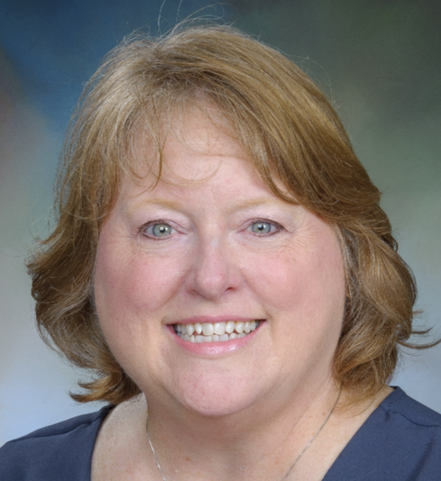
I am deeply honored to have been nominated for a position on the ANPD-H Board of Directors for 2025. With 15 years of experience in nursing education, I am passionate about supporting both new graduate nurses as they transition into practice and experienced nurses as they continue their professional development. These transitions are critical moments in a nurse's career, and I provide the guidance and resources needed for success.
I believe that being actively engaged in a professional organization, such as the ANPD-H, is crucial for both personal and professional growth. Professional organizations offer invaluable opportunities for networking, connecting with other professionals, and forming collaborations and mentorships. These connections foster a sense of community and provide a wealth of resources for ongoing education and career advancement.
Involvement in professional organizations is essential for long-term success. It allows for skill enhancement, keeps us informed of the latest best practices, and helps maintain the relationships that are vital for career progression. If elected, I look forward, to the opportunity to contribute to the ANPD-H Board of Directors and work alongside fellow leaders to further our mission of advancing professional development for nurses at all stages of their careers.

- Emily DeMarco, MSN, RN, NPD-BC, CCRN
Director of Professional Practice and Training
Hawthorne Health Inc.
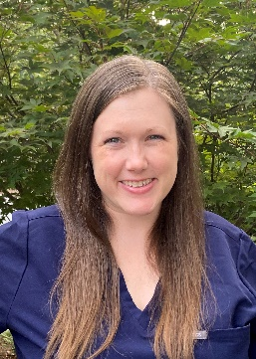
I was born and raised in West Virginia and received my BSN from West Virginia University. My clinical background is in Pediatric Critical Care and Pediatric Cardiac Critical Care. I lived in NYC for almost 10 years where I got into NPD as a Pediatric Critical Care Clinical Educator. I received my MSN in Nursing Education from Gonzaga University. I spent 4 years in the DC/Northern Virginia area as a PICU/PCICU NPD Specialist. I have been in Texas for a little over three years now, working as a Clinical Specialist for Berlin Heart Inc, and most recently moving into a Director Role at Hawthorne Health. I have been in NPD for just over 10 years and received my certification 6 years ago. On a personal note, my partner, and I live in The Woodlands with our two pups, Maui and Archie. He is a sous chef, and we just bought our first house! I love reading good books, listening to good music, eating good food and hiking (when it is not too hot).
I am excited to get involved with ANPD-H to build my network here in TX. My new role is completely remote, and I have seen through the years how valuable it is to have a tribe to bounce ideas off and learn from. We all know that much of what we do is learning as we go and having this community is so important. I believe that as NPD practitioners and specialists, we have the responsibility to advocate for our profession and to demonstrate just how valuable we are. What a better way to do that than to be involved in organizational leadership. As either the Co-Communications or Co-Membership Director, I believe that my strong communication skills, my excited and innovative love for NPD, and my interest in building a strong community of support and mentorship would be a valuable asset to continue to move our ANPD-H community forward.

- Marla Eovaldi, MSN, MBA, RN, NPD-BC
Transition to Practice Site Coordinator
Memorial Hermann Southwest Hospital
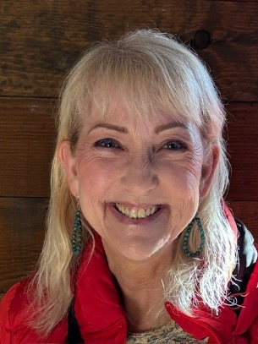

Influential nursing professional development specialist with three decades of nursing experience: background practice in critical care; served in nursing leadership, leadership development, and nurse residency; currently the Transition to Practice Coordinator for Nurse Residency and Fellowship at Memorial Hermann Southwest Hospital. Teaching, leading and serving our nurses with creativity and enthusiasm fills my cup.
I am eager to contribute my project management, leadership, and nursing professional development expertise to this role. My experience has equipped me with the skills to effectively plan, organize, and execute professional development initiatives. I am passionate about fostering a culture of continuous learning and believe that by collaborating with our team, we can create innovative programs that empower our nursing professional development specialists.

- Veena Hopson, MSN, RN, MEDSURG-BC, NPD-BC
Nursing Professional Development Leader
Houston Methodist Continuing Care Hospital

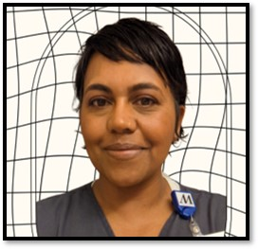

I have 19 years in healthcare with a strong foundation in nursing, instructional design, and technology integration. My passions are improving staff engagement and enhancing patient care through fostering individual growth and incorporating helpful technologies. Currently, I’m a Professional Development Leader with Houston Methodist’s Continuing Care Hospital in the TMC.

For many years, my roles have centered on training, coaching, and project management. In the past few years, I coached healthcare teams across the US in integrating virtual care models, developed many electronic educational modules and administrated learning management systems, facilitated large training cohorts, and leveraged data analysis to improve quality-of-care initiatives. Starting as an ADN nurse back in 2005, I have since earned a Master of Science in Nursing Education and hold Nursing Professional Development and Medical-Surgical Nursing board certifications through the ANCC.

I am interested to join the board Co-Secretary because my varied experience would allow me to represent the diverse interests of ANPD-H members while myself learning from more experienced nursing professional development colleagues.

- Kelly La Frentz, MSN, RN, NPD-BC
Associate Director, Nursing Workforce
MD Anderson Cancer Center

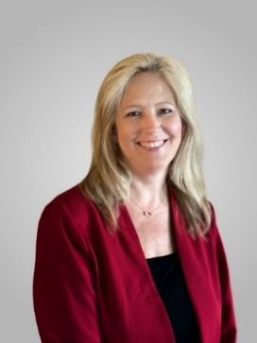

I have been a nurse for almost 30 years with experience in the areas of Pediatrics, Med-Surg, Geriatrics, Solid-Organ Transplant, Nursing Management, and Nursing Professional Development. I received a LVN and ADN nursing degree from San Jacinto College, a BSN from Regis University, MSN in Nursing Leadership & Administration and a Post-master’s in nursing education from UT Health Science Center - Houston. I was the first nurse hired to the Nursing Workforce Department at MD Anderson in 2005 to develop and implement the Clinical Nurse Residency Program, Rising Stars, and Academic Cohort Programs. I have a passion for mentoring and coaching students and new graduate nurses. My current role at MD Anderson is Associate Director – Nursing Workforce where I oversee our recruitment and retention nursing programs that impact students, new graduates, and experienced nurses throughout the institution. I have been actively involved in ANPD and ANPD-H for almost 20 years. I am certified in Nursing Professional Development and serve as a ANCC PTAP Appraiser. Additionally, I have presented and published on a variety of topics related to nursing professional development. I have experience with each of the ANPD-H board roles, including the role of President twice. I feel that as we are celebrating the 25th year of our affiliate that I have the knowledge and history to be very successful in the role of co-Historian.

- Yvonne Mack, DHA, RN, VHA-CM
Nursing Professional Development Practitioner
Charge Nurse Development Program Director
Elsevier/Lexi-Drug Nursing Resource Administrator
Clinical Practice Office
Michael E. DeBakey VA Medical Center

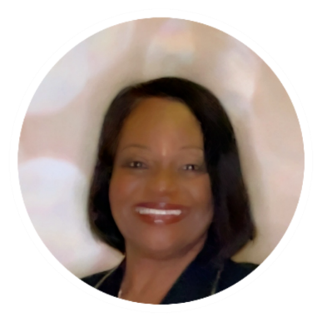

I have served as a nurse educator for over forty years in staff development, patient education, and community education. Leadership in healthcare community partnerships is important to me. In 2018, I had the unique distinction of serving as one of the organizers of the First Annual Nurses Night Out, a Nurses Week event hosted by several Texas Medical Center healthcare organizations that was attended by the mayor of Houston, Texas Sylvester Turner. Serving as the Past President of the Association for Nursing Professional Development Houston Affiliation (ANPD-H) from 2017-2018 was an extreme honor that provided the opportunity to serve through advocacy, program management, and mentorship. As a Nursing Professional Development Practitioner for the Michael E. DeBakey VA Medical Center, the second largest VA in the nation, my role has enabled me to advance the Association for Nursing Professional Development (ANPD) core values and practice.
As a Veteran’s Administration Certified Mentor and Coach, I hope to expand on the achievements of ANPD-H throughout its local and national outreach affiliations.
My personal philosophy is that “Every Nurse is a Leader”, from the graduate novice to the boardroom executive and I will continue to pursue nursing excellence, accelerate influence, and support transforming healthcare across the continuum.

- Tanya Nelson Hall, MSN, RN, RNC-NIC, NPD-BC
Nursing Education Specialist
Nursing Professional Development – Clinical Training
Texas Children’s Hospital
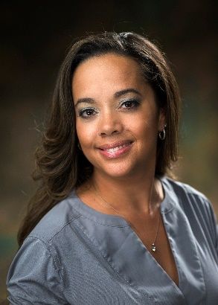
Tanya Nelson-Hall is a Nursing Professional Development Specialist with a nursing career spanning 20 years in neonatal intensive care and education. She has a master’s degree in nursing education and currently leads programs for onboarding clinical staff, regulatory readiness related to competency management, and incorporating innovation into nursing skills education. She is passionate about mentoring NPD practitioners, innovative education, and interdisciplinary collaboration. Tanya has served as a board member for ANPD Houston-affiliate for the past 2 years and enjoys networking & collaborating with fellow NPD practitioners.

- Cynthia Rittenhouse, DNP, RN, NPD-BC, EBP-C
Education Resource Specialist III
System Clinical Education
Memorial Hermann
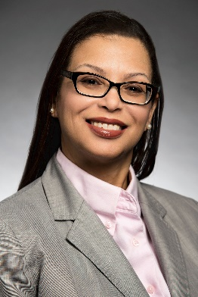
I have been a nurse for 27 years and in that time, I have had the opportunity to experience various nursing roles from bedside nurse to mentor/preceptor to informal/formal leadership. Out of all those roles I have always loved mentor/preceptor the most. It fills my cup to be a Professional Development Specialist. Watching people grow and develop in their professional journey is very satisfying and fulfilling to me. In all of this, I feel that I am a leader and resource to others as we all grow and develop together. With that, I am honored to be nominated for President Elect.

- Yashamika Short, DNP, RN, NPD-BC
Clinical Manager, Acute Care of the Elderly
Memorial Hermann Texas Medical Center

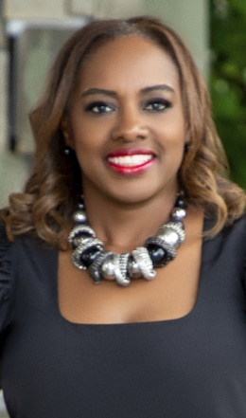
Yashamika Short is a woman who loves to explore new experiences along with traveling, reading, and gardening. She is a wife and a mother of 2. Yashamika is also a Registered Nurse (RN) with 24 years of experience ranging from Trauma Critical Care to Education. Yashamika currently holds a Master of Science in Nursing (MSN) with a focus in Nursing Education and a certification in Nursing Professional Development. She recently graduated with her Doctor of Nursing Practice degree with a Nurse Executive focus from University of Texas Health Science Center.

Yashamika’ s previous position entailed facilitating a Transition to Practice Program for new nurses at a large teaching hospital in Texas. In this position she was able to offer emotional and professional support, tools for transition, and resources. Due to the relationships and success in the role it was placed on her heart to share that beyond the walls of her organization. That desire birthed her book Navigating Nursing: A Practical Guide for the Novice Nurse from A to Z.

Yashamika has a passion for professional development feeling everyone should be equipped to perform their duties to the best of their abilities regardless of the role.

She has received numerous awards and recognition with most recently being nominated for Vizient Nurse Residency Program Coordinator of the Year, Daisy Leader, and Nurse Excellence Award for Compassion.
Her motto: Life has so much to offer so go out and capture it ALL. See beyond your sight.

- Heather Wallace, Ph.D. (c), RN, NPD-BC
Market Director National Nurse Residency Program
Brazos Valley, East TX and Houston
CommonSpirit Health
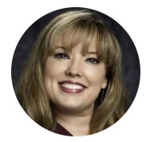
Heather Wallace is a Ph.D. Candidate, RN with >25 years of experience in nursing leadership, professional development, education, Magnet®, and PTAP® designations. She then graduated with her MSN, Ed, from the University of Texas at Tyler in 2008. She is now pursuing a Ph.D. in Nursing at the University of Texas Health Science Center, focusing on nurse residents with neurodiversity. She has been certified in nursing professional development for over 15 years and is working on her portfolio for NPDA-BC.
She has worked in academic medical centers and community hospitals and taught for ADN and BSN programs. She worked at Baylor St Luke's Medical Center in the Texas Medical Center for seven years, serving as the co-coordinator for the first nurse residency program in Houston to attain Practice Transition Accreditation Program (PTAP) with Distinction in 2018 and has now achieved re-accreditation. In 2023, she assumed the role of Market Director of Nurse Residency for CommonSpirit Health, with oversight of three TX markets.
Heather has been on the ANPD-H board for over 15 years, serving in every board role at one time or another. She is excited to continue to serve this fantastic community of NPD practitioners as either Co-Secretary or Co-Membership Director. Heather maintained our affiliate records by creating our Google Drive and initial website several years ago. She sees her role as mentoring the next generation of NRP practitioners, and a board appointment allows her to continue to share our legacy and create our future.

- Gayle Young, MSN, RN, NPD-BC
Nursing Professional Development Specialist
Texas Children’s Hospital

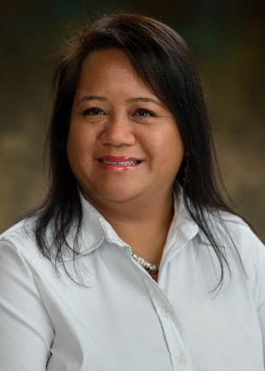
I am a registered nurse with almost 30 years of experience in pediatrics, including emergency and critical care. I have 15 years of experience in nursing professional development at both the unit level and the system level. I currently lead simulation resuscitation education and contribute to our Nurse Residency and Approved Provider Programs. I have been an active ANPD-H BOD member for the past 3 years leading the both the communications team and the programs team. My most recent accomplishments on the programs team include implementing journal and podcast discussions and writing for CE credit for the professional development programs. I am honored to be nominated as a co-lead for the membership team. I am passionate about fostering collaboration among NPD practitioners and am eager to drive innovative strategies to enhance membership recruitment and engagement. Thank you!

