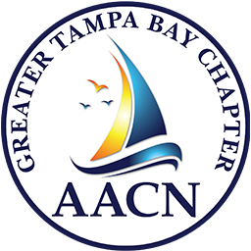
Membership Drive / Contest

Please PRINT out all information, and bring to Meeting or send us an Email attachment no Later than December 12!
This contest is from January 1 through December 12, 2024!
*Winner will receive complimentary attendance at Tides, 2025!

- Member Name: ___________________________________________________

  - Membership since: __________________________________________

- Members You have Recruited Month Joined - Verified by Treasurer
_____________________________________________________________________________
______________________________________________________________________________
_____________________________________________________________________________
______________________________________________________________________________
_____________________________________________________________________________
______________________________________________________________________________
_____________________________________________________________________________
______________________________________________________________________________
_____________________________________________________________________________
______________________________________________________________________________

Signature of Recruiter: __________________________________ Date:____________________

