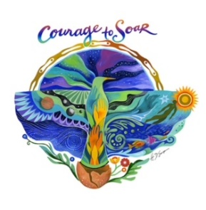

**Nurse’s Night Out!**

**We are changing things up!**

**November 20th, 2024**

Edwards Lifesciences presents:

***Hemodynamics: Shock and Patient Monitoring***

Dr Eddy Gutierrez, critical care intensivist and author of *The Vasopressor and Inotrope Handbook* will join us virtually from Jacksonville, Florida.

Join us at **The Hot House** (New Venue)

N88 W16631 Appleton Ave, Menomonee Falls, WI 53051

5:30 Networking and Social Gathering

5:55 Announcements

6:00 Buffet style dinner

6:15 Presentation by Dr Eddy Gutierrez

**This is a FREE event. All participants need to RSVP to** [**Milwaukeeaacn@gmail.com**](mailto:Milwaukeeaacn@gmail.com)**.**