**Daytona Beach Black Nurses Association**

**e- NEWSLETTER**

**Fall 2024**

**EVENTS CORNER MEMBERS SPOTLIGHT**

**SEPTEMBER**

**Laps For Literacy: September 21, 2024**

**Healthier Wealthier Wiser: September 28, 2024**

**OCTOBER**

**BCU Homecoming: October 26, 2024**

**NOVEMBER**

**Healthier Wealthier Wiser: November 2, 2024**

**DECEMBER**

**Holiday Celebration**

**CONGRATULATIONS SCHOLARSHIP RECIPIENTS**

**2024**

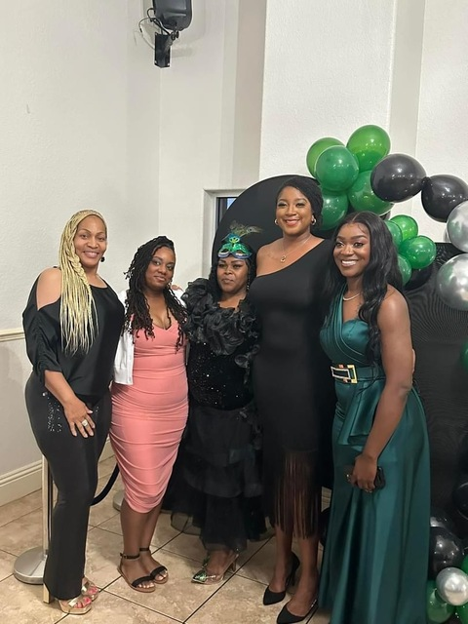

**Tina Carlyle, MSN, RN**

**Shanikwa Johnson, BSN, RN**

**Sylenthia Robinson, student**

**Rickae Jinks, BSN, RN**

**Jessica Estevez, student**

**Shanikwa Johnson, MSN, RN**

**Moses Conforte, RN**

**EDUCATION ACCOMPLISHMENTS**

**CONGRATULATIONS**



**CDC Health Awareness Months**

**OCTOBER**

**National Breast Cancer Awareness Month**

**Health Literacy Month**

**National Domestic Awareness Month**

**NOVEMBER**

[**Lung Cancer Awareness Month**](https://www.cdc.gov/cancer/features/lung-cancer.html?CDC_AAref_Val=https://www.cdc.gov/cancer/dcpc/resources/features/lungcancer/index.htm)

[**National Family Caregivers Month**](https://www.cdc.gov/aging/publications/features/caregivers-month.html)

[**American Diabetes Month**](https://www.cdc.gov/diabetes/risk-factors/diabetes-and-women-1.html?CDC_AAref_Val=https://www.cdc.gov/diabetes/library/features/diabetes-and-women.html)

[**National Alzheimer's Disease Awareness Month**](https://www.cdc.gov/aging/index.html)

**DECEMBER**

[**World AIDS Awareness Month**](https://www.cdc.gov/hiv/awarenessdays/index.html)

**WELCOME NEW MEMBERS**

**Kendra Barned**

**Pamela Brewer**

**Veronica Cato**

**Angelica Chriswell**

**Ariana Clark**

**Deneshia Green**

**Jacqueline Green**

**Caneika Hogg**

**Erica Jackson**

**Devra Lozada**

**Jennifer Montgomery**

**Chelle Moss**

**Elizabeth Mwai**

**Nicole Trott**

**Dorielle Williams**

**Faithia Wilson**