 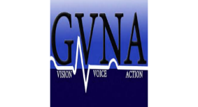

**Coalition of Regional Nursing Organizations (CORNO)**

**Annual October Program Wed. October 9, 2024**

* **Cleary Auditorium, Kearney Hall. St John Fisher University. 3690 East Ave 14610**
* **6:30pm registration and networking**
* **7 pm: Dr. Kenya Beard “Health Equity”**

Dr. Beard served as an Advisory Board Member for the New York Academy of Medicine's Health Equity Scholars and co-authored the National Academy of Medicines' (NAM) Perspectives Dismantling Systemic Racism and Advancing Health Equity throughout Research. She co-authored the 2022 Racism in Nursing foundational report and continues to serve on the National Commission to Address Racism in Nursing

**All Welcome: Healthcare Professionals, Educators/Faculty, Healthcare Students and Administrators.**

**Registration Open on GVNA Website**