**AL NAHN Chapter Meeting Minutes**

**April 25th, 2024 6:00-7:00 p.m. CST via Zoom**

**Members Present:**

Grace Grau

Tiffany Laserna

Jammie Sanchez

Annette Stricklin

Nury Alejandro Rodriguez

Sebastian Becerril Vargas

Sarah Watts

**Members Absent:**

Felesia Bowen

Cesar Esquiagola

Norma Cuellar

Carlos Guerrero

Christine Gil

Maria Shirey

Lindsey Harris

Danielle Dalton

Aida Miles

Maneeza Martin

Cathy Cartagena

Lisandra Hernandez

Zaylie Quick

Felix Garcia

Frank Puga

America Aguilera

Odalyz Montes

Sonia Turner

Javier Figueroa

**TREASURER REPORT – current chapter balance $29,204.97**

* Current Balance: $29,204.97 (28,951.77)
  + Checking $1,969.09 (1,769.89)
  + Savings $ 6,572.74 (6552.56)
  + CDs $20, 663.14 (20,536.52)
    - MATURITY DATE 6/22/2024
    - MATURITY DATE 7/23/2024
* Expenses:
  + Storage Unit $36.90

**MEETING PURPOSE & GOALS**

* Action on Routine Matters through [consent agenda](C://Users/nurse/OneDrive/Documents/ALNAHN/What%20is%20a%20consent%20agenda.mhtml)
* Discussion and action on strategies, initiatives
* Updates from leaders on key Issues

I. Meeting was called to order by Chapter President Dr. Grace Grau at 6:01pm. We did not have a Quorum.

II. Consent Agenda

* Board meeting minutes from February 2024 reviewed by those present.
* Treasurer report provided by Dr. Grau.

III. President Update (provided Dr. Grau)

* ALNAHN
  + Chapter events:
    - Health clinic on February 3, 2024 from 11-4 pm at Holy Family Cristo Rey
    - Hispanic Community Event held in Opelika, AL provided care for approximately 300 people. This family-friendly event included an Easter Egg hunt, food boxes for families provided by the East Alabama Food Bank, food, games and activities, health fair provided screenings and education, and a dental fair provided screenings.
  + Upcoming volunteer opportunities:
    - Children’s Hospital May 10, 2024 – members encouraged to volunteer to meet with nurses and leaders.
    - UAB SON (TBD) – members encouraged to volunteer to meet with nurses and leaders.
    - We will be very active During National Nurses Week and Hispanic Heritage month- be alert for calls to volunteer.
  + Upcoming civic engagement opportunity:
    - Dr. Grau shared that only 70% of nurses are registered to vote, encouraged all members to register. There are plans for AL NAHN to collaborate with others to start an initiative to register nurses to vote.
    - Members were encouraged to find their legislator through this link: <https://myreps.datamade.us/>
  + Additional leadership/professional development opportunities:
    - Dr. Grau discussed the upcoming climate health webinar.

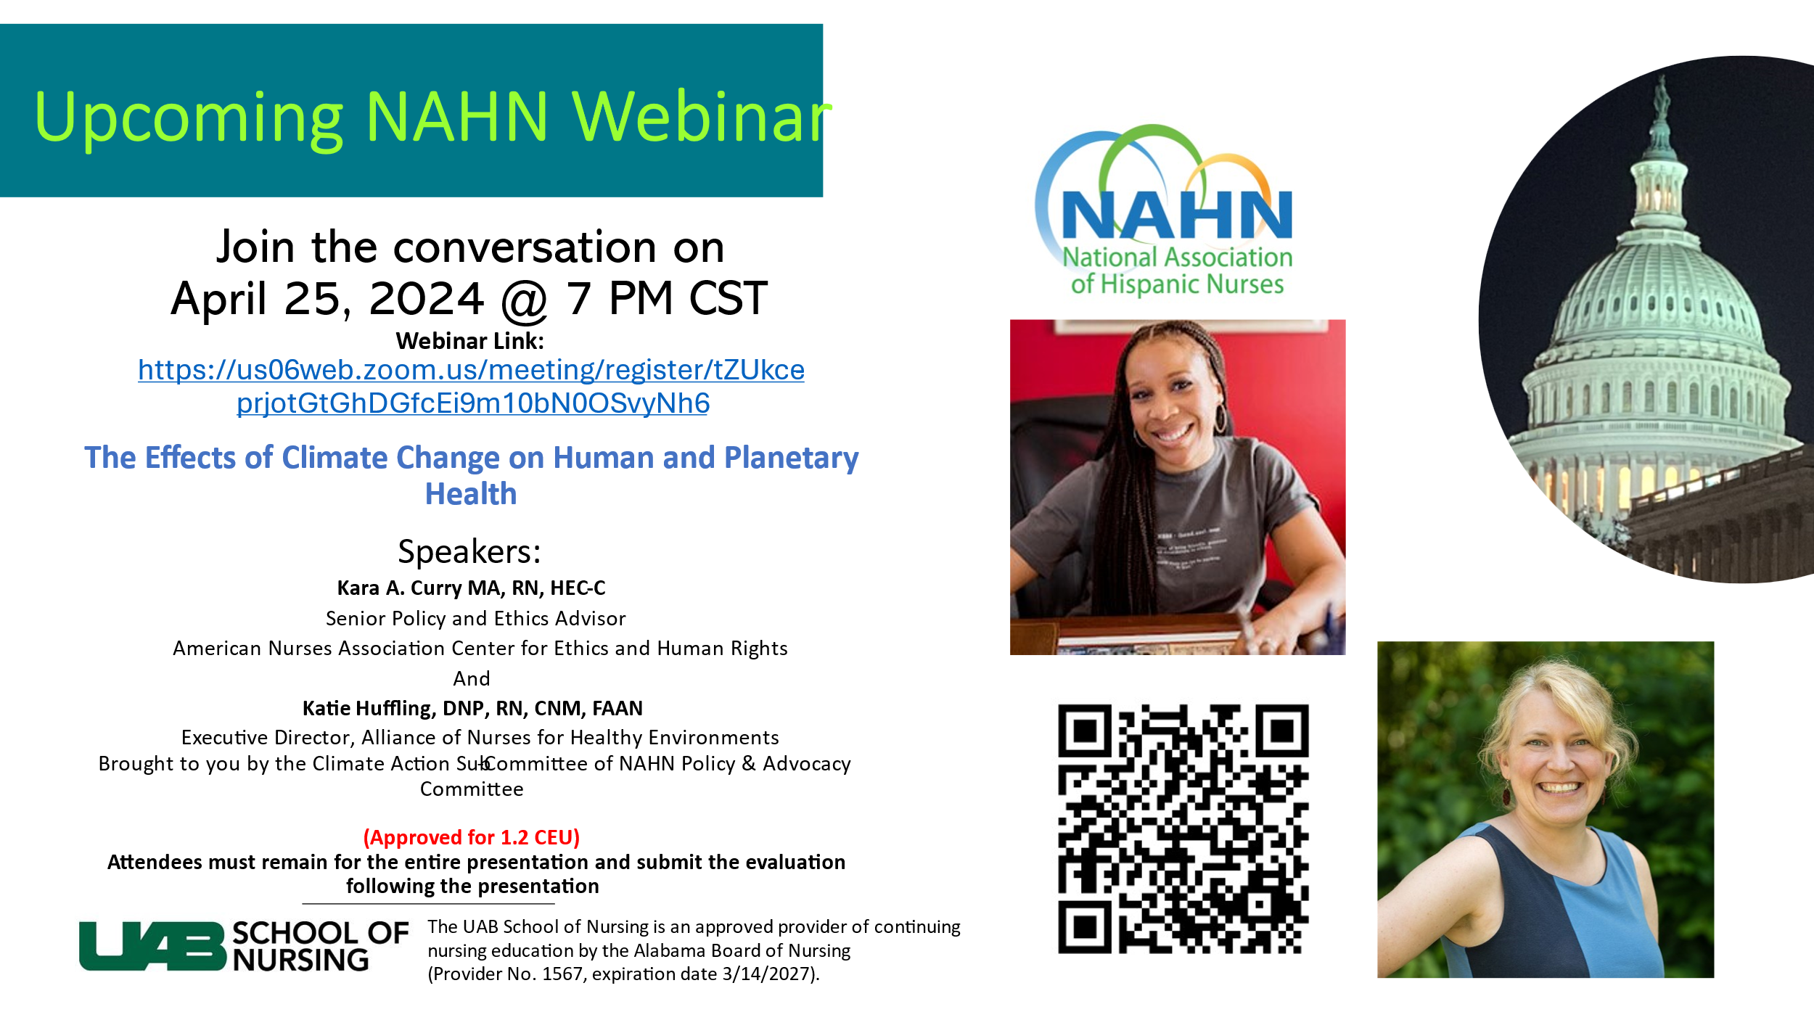[Registration Link](https://us06web.zoom.us/meeting/register/tZUkce-prjotGtGhDGfcEi9m10bN0OSvyNh6)

* **NATIONAL** 
  + Upcoming Elections May 31-June 7, 2024
    - Candidate names shared by Dr. Grau
    - Encouraged members to vote and get to know candidates to see who to vote for (find candidates on LinkedIn or social media).
  + National Conference July 31-August 3 (Atlanta, GA)
    - Fees for hotel and registration was shared.
    - Inauguration will occur during Gala.
    - Sebastian shared his experience, Dr. Grau encouraged all to attend.
    - UAB SON to support NAHN GA’s high school immersion event
    - Leadership Institute will take place on Wednesday, July 31 from 9am – 5pm
    - Student bootcamp will take place Wednesday, July 31st (all students must attend).
      * + Chapter Leadership Discount for LLI
        + $80 off LLI registration ($119 instead of regular $199 rate)
* Student Info:
* Student cost for conference is $250.00 (due by Jun 14th). NAHN AL will cover hotel expenses.
* The sponsorship opportunity is limited to those with an active student membership in NAHN (the code will only work if they have a student membership).
* The sponsorship is limited to the Annual Conference registration (July 31 – August 1). It does not include transportation, meal, lodging expenses, Latino Leadership Institute, or gala tickets.
* Policy:Please see the [NAHN National Conference Student Sponsorship Policy](https://amr.sharepoint.com/:b:/s/amrfiles/EUWIVZQBuY9OqkPR6wYghRABBkFyqbA2qpt7YFjjWc-1oA?e=TErhp3) for full requirements. Please review the policy for the student sponsorship so you are aware of your role and expectations at the Annual Conference.

IV. Items for discussion and action –

* All members should create and update profile on [NAHN Alabama website](https://alnahn.nursingnetwork.com/).
* Dr Grau discussed letter of support for I3 Academy. She is hesitant to agree to sign a letter of support because we aren’t being asked to participate in the project, just show the support for it. Tiffany felt we should support the project. Dr. Sarah Watts wanted to know how the grant will support the 30% of Hispanic students in the school. Dr. Grau will reach back out to the organization to get more information.

V. Round Table/Member sharing

* Tiffany shared excitement to hear Dr. Grau is running for NAHN President.

The next meeting will be held June 27th, 2024- 6 -7 pm

Meeting adjourned at 6:41pm by Dr. Grau.