

Please join us for our next IANPD Affiliate Meeting
When: September 27th 2024
10:00am – Noon CST/11:00am-1:00pm EST
- 10:00 – 10:30 CST
  - Affiliate Meeting/Election nomination review & voting
- 10:30a- 11a CST
  - Professional Development Offering: Spirit of Inquiry for NPD practitioners
- 11a-12p CST
  - Professional Development Offering: Showing the Value of NPD
Where: Franciscan Physician Network Medical Center, 757 45th Street. Munster, IN 46321
Virtual Option: Teams link in email invite and below
Professional Development Offering:

Spirit of Inquiry for the NPD Practitioner
Speaker: Omar Ali MSN, RN, NPD-BC
Nurse Staff Development Coordinator for Eskenazi Health

Showing the Value of NPD
Speaker: Stacey Junger DNP, RN, NPD-BC, CPN
Director of Nursing Practice for Indiana University Health West Hospital

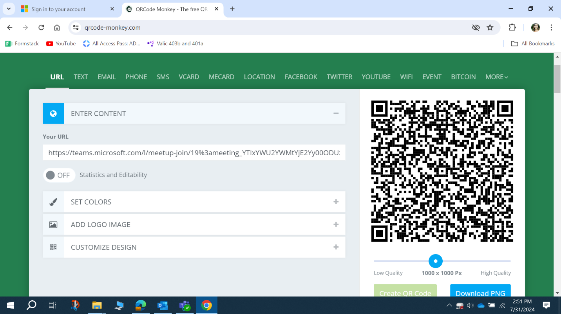
Microsoft Teams Need help?
Join the meeting now
Meeting ID: 261 030 822 927
Passcode: iyRCCU

Dial in by phone
+1 260-247-8406,,208302299# United States, Fort Wayne
Find a local number
Phone conference ID: 208 302 299#

Franciscan Health is approved as a provider of nursing continuing professional development by the Maryland Nurses Association, and accredited approver by the American Nurses Credentialing Center’s Commission on Accreditation. 1.5 CEs provided

