NACDN Board of Directors Announces Leadership Change

In July 2024, NACDN President Heather Young, *MSN, CRNP, FNP-C, CSAP* notified the Board of Directors of the need to regretfully step down from her position before the end of her term. President Young recognized the important work being done at NACDN and did not want to have life events interfere with the forward progress of the organization. President Young is credited with recognition of the need to revamp processes for national certification, the updating of the Certification Exam, the facilitation of the 1st Dine & Learn event, the introduction of the NACDN Board of Directors to consultant Terri Goodman, and promoting NACDN at conferences. President Young looks forward to contributing to the NACDN mission in the new year.

As the NACDN Vice President, per NACDN Bylaws, I have stepped in to the President’s role to finish out President Young’s term. As a long-time member of MACDN and now NACDN, I look forward to serving NACDN over the next 6 months and appreciate the support and confidence of the NACDN Board of Directors.

I look forward to making the remainder of 2024 a productive one. I welcome all new NACDN members and those renewing, and am excited to welcome Committee Chairs, Corinne Borel (Education) and Tara Weinkam (Membership) to the Board. The Certification Committee Chair has yet to be named, but will be finalized soon. Interested in making a difference and growing NACDN as a Committee Chair or Committee member? Contact NACDN or any Board member to lend your voice.

Gloria Olivares, FNP-BC

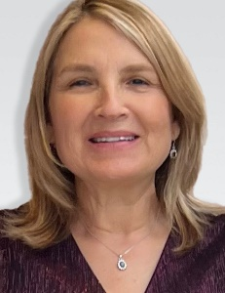

President, NACDN

[golivares@nacdn.org](mailto:golivares@nacdn.org)

(P)410-849-0525

(F) 410- 941-6833

