*Register by 11:59PM on Thursday, August 8 to have the chance to win one of these fantastic prizes!*

**$250 Gift Certificate**

Generously donated by The Nash Group, this is your chance to be put into a raffle to win a cash gift card for $250!

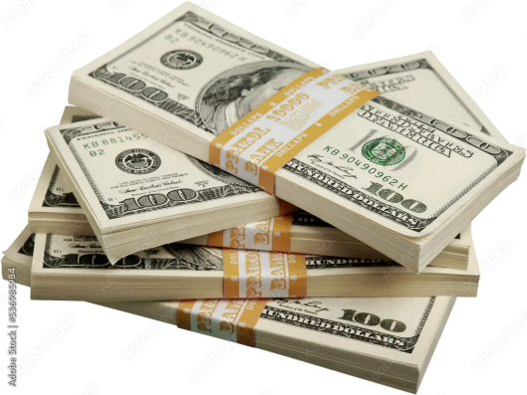

**Pre-season Packer Tickets**

Be put into a raffle to win two (2) tickets to the *Saturday, August 24 12:00PM* pre-season Green Bay Packer game against the

Baltimore Ravens.

WONL board members, conference sponsors, exhibitors and speakers are not eligible

to win these raffles.



For more information on the conference, including registration, please click [**here**.](https://www.wha.org/AboutWHA/CalendarofEvents/Conference/WONL-2024)