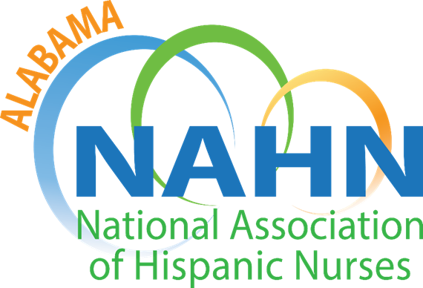

Alabama Chapter of the National Association of Hispanic Nurses
Promoting Hispanic Nurses to Improve the Health of the Hispanic Communities

July 23, 2024

National Association of Hispanic Nurses AL Offers three Student member scholarships/year. Applicants are advised to carefully read through the requirements before completing the application form and ordering the required transcripts.

BASIC REQUIREMENTS and 2024 AWARD AMOUNTS
- Eligible candidates must be enrolled to take prerequisites to enter into a nursing program OR must currently be enrolled in an accredited nursing program (including LPN, ADN, RN to BSN, BSN, MSN and/or doctoral program) and be in good academic standing at the time of application. Candidates do not have to be of Hispanic descent but must be a member of NAHN AL chapter for 6 months preceding application.

There are currently four scholarships available this year in the amount of $1000, $500 and 1 scholarships of $200 each (for students graduating within the upcoming year for reimbursement with NCLEX receipt).

Nursing students (regardless of ethnic origin) nearing graduation may apply for the scholarship to help cover the costs of NCLEX prep and/or exam fees. These students must show evidence of at least one-year existing membership to AL NAHN.

ABOUT NAHN- AL chapter
The Alabama chapter of the National Association of Hispanic Nurses™ was established in 2016. AL-NAHN is a group of healthcare professionals, including nursing students, who work together to improve the health of Alabama Hispanic residents. As a group, we support efforts to increase the number of Hispanics entering the Healthcare field, specifically nursing. We encourage Hispanic nurses to further their education enabling acceptance of leadership and/or advanced clinical roles. We provide educational opportunities for all chapter members, as well as the community. We are small, but a growing chapter of dedicated persons who strive to improve the health of our Hispanic communities and advocate access to culturally competent, quality healthcare for all Hispanics. We are Alabama NAHN.

APPLICATION DEADLINE: The are two types applications~
- Applications for general scholarships and NCLEX Prep exams can be submitted until August 16 . Award announcements will be made by August 23, 2024.

The scholarship committee looks forward to reviewing your qualified applications.

Scholarship Requirements
- Candidates DO NOT need to be of Hispanic descent but must be members of AL NAHN
- Candidate may be taking prerequisites to enter a nursing program OR someone currently enrolled in an accredited nursing program (including LPN, ADN, RN to BSN, BSN, MSN and doctoral program).
- Cumulative GPA ≥ 2.7
- Awardees are required to sign a contract agreement to remain an active member of AL NAHN which will include completing one of the following projects within one year of receiving the scholarship:
  - Provide health education to Hispanics through community programs
  - Mentor a new nursing student
What You Need to Complete Your Scholarship Application
To be considered for this chapter scholarship, you will need to complete an application and submit all necessary documentation. You must have at least one full year remaining in nursing school.

- Scholarship Application & supporting documentation submitted by email ggraudnp@gmail.com or
- mailed to
Grace Grau/AL-NAHN
976 Valley Circle
Leeds, AL 35094

- Official transcript from an accredited School of Nursing OR current school
- Proof of membership/Copy of NAHN membership card
for membership information go to https://www.nahnnet.org/NAHNMembership.html
- Essay (Your short essay should include a description of extracurricular activities and community service/involvement. These may include local chapter activities, community-based projects, school level projects, organizational efforts / state level student activities, activities impacting the health and social condition of Hispanics and other culturally diverse groups. Also include your ideas on what you can do as an individual nurse to improve the health status and/or social condition of Hispanics and a statement about your future goals in nursing.)
- One letter of recommendation (from a teacher or employer, written within the past 6 months)

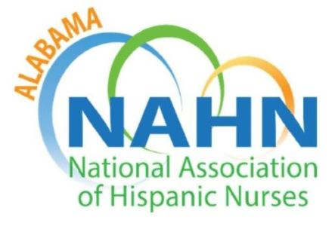

National Association of Hispanic Nurses/ AL Chapter
Application for Scholarship
Application type_____________ (NCLEX prep or Tuition)

Please Type or Print clearly in Ink

Name:

Daytime Phone#:

Current Address:

City, State, Zip Code:

Place of Employment (if applicable): _________________________________

NAHN Member #: ________ Year joined: __________

Do you currently hold a Nursing License? Yes  No
If yes: License Number: _____________________State ________________

Other anticipated sources of income: i.e. family, scholarship, grants, loans, veteran benefits, etc. If None , please state none. Please list ALL and amounts:

Current School of Nursing Enrollment
Name:
Address:
City, State, Zip Code:
Dean/Director & school phone #: _______________________________________
Type of Nursing Program – Circle One: LPN ADN BSN RN to BSN MSN DNP/PhD
Expected Graduation Date:

Signature / Date
I hereby affirm that all the information provided is true. Any false statement will forfeit the award.

