**Save the Date!** 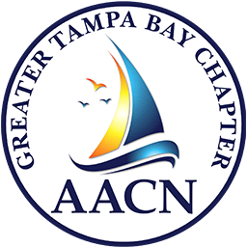

**MARK YOUR CALENDARS!**

**Greater Tampa Bay Chapter**

of the

*American Association of Critical Care Nurses*

PROUDLY PRESENTS

OUR 23rd

**CRITICAL TRENDS**:

***TIDES OF TAMPA BAY***

**Saturday February 22, 2025**

8:00am – 1:00pm

AT

St. Joseph’s Medical Arts Building Auditorium

3003 W. Dr. Martin Luther King Blvd

Tampa, Florida 33607

Information/Registration will be posted on our website as

soon as updated information is available:

*aacntampa.nursingnetwork.com*

