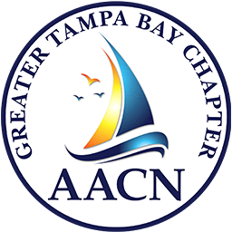

Greater Tampa Bay Chapter of the

American Association of Critical Care Nurses



Partners with Lincoln Elementary Magnet School – Plant City

**Back to School Supply Drive**

**Most requested Needs for Teachers:**

* **Expo Markers – especially black ones (ok if store brand)**
* **Tissues**
* **Band-aids**
* **Lysol Wipes**
* **Sticky Notes**
* **Glue Sticks**
* **Index Cards**
* **Card Stock Paper**

**\*\*NOTE: Children also need basic supplies (pencils, pens, paper & notebooks, etc.) and teachers will save some for second half of year to hand out as needed.**

**Many students showed up to school last year without a 1-inch binder (due to expense) that is needed for many of the grades.**

**THANKS!!**