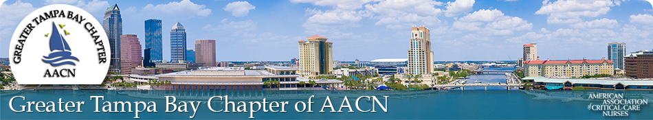

Looking for professional nurses interested in networking and collaborating with local members of National AACN!

$30 annual membership includes sponsored educational dinners and

recognition of excellecence

Join NOW!

https://aacntampa.nursingnetwork.com

Recruitment award for highest amount of referrals

from current members

***Free Admission to 2025 Tides of Tampa Conference**

[American Association of Critical-Care Nurses](http://www.aacn.org/default.htm)