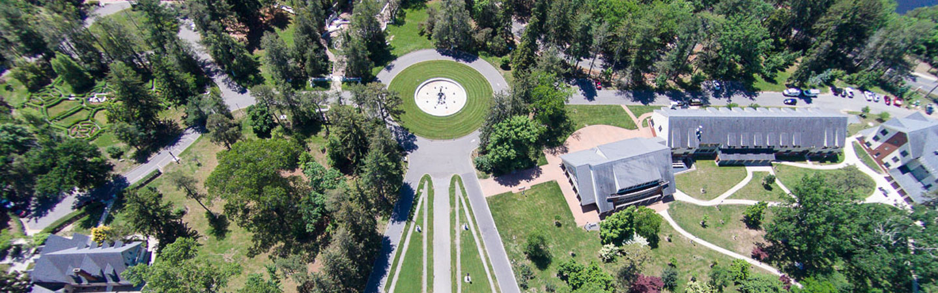
Lakewood Campus
Georgian Court University
900 Lakewood Avenue
Lakewood, NJ 08701
800-458-8422
admissions@georgian.edu
Campus Map
Click here for GPS directions to the Main Entrance.

FROM NORTHERN NEW JERSEY, NEW YORK, OR NEW ENGLAND:
Take the Garden State Parkway South to Exit 91B Lakewood. Stay in the center lane and follow Route 549 Lanes Mill Road South. Make a right onto Route 526 West (Lanes Mill Road, which becomes County Line Road). Go approximately 4 miles and turn left onto Route 9 South. Turn right onto Ninth Street; the Main Entrance is on the right.
- Office of Admissions:
The Office of Admissions is located in the Welcome Center of Mercedes Hall which is indicated on the Campus Map.

FROM NORTHWEST NEW JERSEY OR PENNSYLVANIA:
Take I-80 East or I-78 East to I-287 South to the Garden State Parkway South. Take the Garden State Parkway to Exit 91B Lakewood and proceed as above.

FROM COASTAL SOUTH JERSEY:
Take the Garden State Parkway North to Exit 90 Brick. Stay to the right and immediately take the first jug-handle for U and left turns. Stay to the left and turn left at the traffic light onto Chambersbridge Road (Route 549). Continue going straight on Route 549 as Chambersbridge Road becomes Lanes Mill Road. Make a left onto Route 526 West (Lanes Mill Road, which becomes County Line Road). Go approximately 4 miles and turn left onto Route 9 South. Turn right onto Ninth Street; the Main Entrance is on the right.
- Office of Admissions:
The Office of Admissions is located in the Welcome Center of Mercedes Hall which is indicated on the Campus Map.

FROM SOUTH JERSEY-PHILADELPHIA AREA, DELAWARE, OR MARYLAND:
Take I-95 North, I-295 North, or the New Jersey Turnpike North to I-195 East (Exit 7A from the New Jersey Turnpike). Take I-195 East to Exit 28A. Follow Route 9 South to Ninth Street (approximately 6 miles). Turn right onto Ninth Street; the Main Entrance is on the right.
- Office of Admissions:
The Office of Admissions is located in the Welcome Center of Mercedes Hall which is indicated on the Campus Map.

FROM BROOKLYN, STATEN ISLAND, OR LONG ISLAND:
Take the Belt Parkway West to the Verrazano Bridge to the Outerbridge Crossing. Take 440 South to the Garden State Parkway South to Exit 91B Lakewood. Follow directions “From Northern New Jersey, New York, or New England.”

GROUND TRANSPORTATION:
New Jersey Transit regularly provides buses to and from New York City and Philadelphia to the Lakewood Bus Terminal. Taxi service is available from the bus terminal to the university (less than a 10-minute drive).

