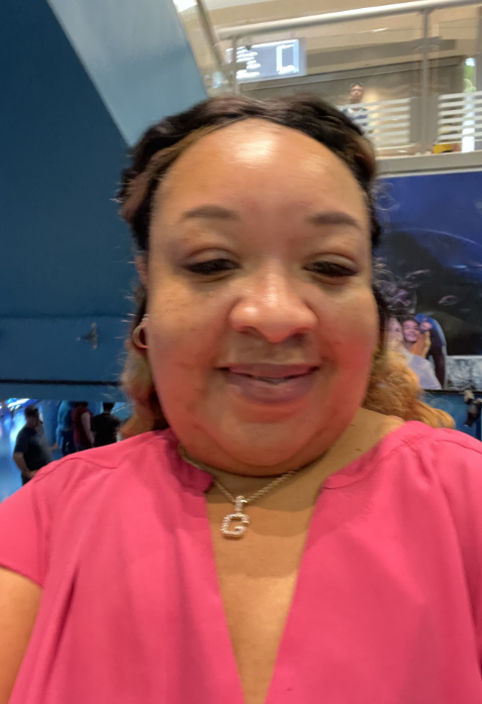
April D. Gould achieved her Associate Degree in Nursing June of 2001 and after unsuccessful test re-tested and achieved her Registered Nurse Licensure in November 2001 in Oxford, MS. August of 2004, Ms. Gould completed her bachelor’s degree in nursing and accepted a position in the float pool at St. Louis University Hospital where her leadership and eagerness to learn allowed her to gain the experience as a transplant nurse doing the post-op day of a kidney and liver transplants. The Department of Veteran Affairs and is what started her leadership roles and promotion to Nurse Manager while in the VHA in St. Louis, Mo. Ms. Gould achieved Master of Christian Ministry December 2010 and went on to complete her Master of Health Administration August 2013. June 2019, Ms. Gould accepted a Nurse Manager position at the North Dallas VA Medical Center shortly after arrival Ms. Gould was utilized to activate a all-private room Med-Surg Telemetry Acute Care Inpatient Unit and has been achieving positive outcomes and accolades, since activation. 6C-400 has gone for the lowest turnover rate for 3 consecutive years, has achieved the Servant Leadership Distinction and our medical center received the Pathway to Excellence Distinction and is presently transitioning toward being Magnet and a High Reliability organization creating a Just Culture to do no harm and being pre-occupied with process improvement.
A Fun Fact about April Gould, she is CEO/Founder of 2 LLC’s Lasting Legacy Rentals and New Legacy Enterprises/ Jani King Franchise and she loves to travel.
Has been with the VHA since 2/8/2008 started at the VHA Medical Center in St. Louis, Mo. And transferred to the VHA North Texas 6/19/2019.

