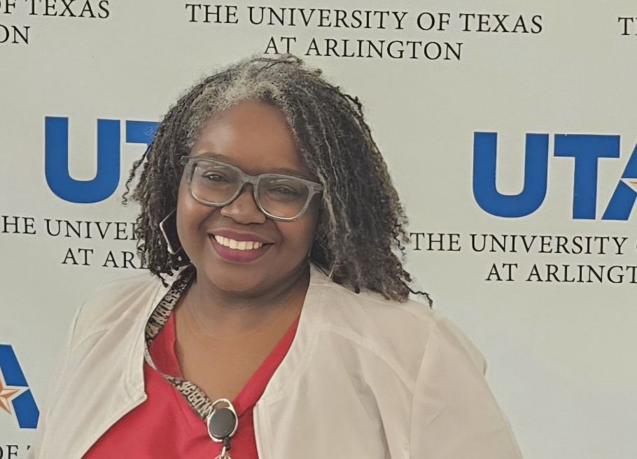
Robin Hunter MSN, RN
I begin my Nursing career as a Nursing Assistant and found this passion for caring for the elderly. I worked my way from Nursing assistant to medication aide on to LVN then I was encouraged to get a job working at the VA Hospital after taking my father there. Soon after I transitioned to ADN on to a BSN then completed MSN in 2013 at the University of Texas at Arlington.
I have worked at the VA Hospital for 23yrs and 8months and have worked as a Staff Nurse, Nurse interim and in the role of Nurse Consultant. My current role is Clinical Informatics Nurse, where I bridge the gap between the RN and IT.
In my pass time I work as Adjunct faculty for the University of Texas at Arlington (UTA), I truly enjoy sharing my experience and skills with the next generation of Nurses.

