Yankees Healthcare Appreciation Week 2024!

For the 2024 MLB season, the New York Yankees are offering six games with Healthcare Appreciation Week where we will be showing our gratitude for all our healthcare professionals! We will be offering discounted tickets to all medical professionals along with their friends and families.

Each Special Event Ticket includes:
- Either a New York Yankees Scrub top or tumbler co-branded with our healthcare appreciation logo
- $15 New York Yankees Food & Beverage Voucher* (ONLY FOR 5/20, 5/21, 5/22, 5/23 GAMES)

Healthcare Appreciation Games will be played on the following dates:

5/17 – NYY vs. CHW
5/18 – NYY vs. CHW
5/19 – NYY vs. CHW
5/20 – NYY vs. SEA
5/21 – NYY vs. SEA
5/21- NYY VS. SEA
Using the link below, once one of the six games is selected, you will be able to see which seating sections are offered at each price; you will also be able to see what the view of the section will look like by clicking “SEATMAP” under each ticket option.

Each buyer be able to use this link to purchase tickets and confirm their own individual orders!

https://offer.fevo.com/new-york-yankees-healthcare-appreciation-62f7f63?ref=Carter

Please feel free to send this over to anyone you think may be interested.

Thank you for all that you do!

27-
Time World Champions
New York Yankees
One East 161st Street

John Carter
Junior Bronx, NY 10451
jcarter@stadiumevents.com
(646) 977-8264

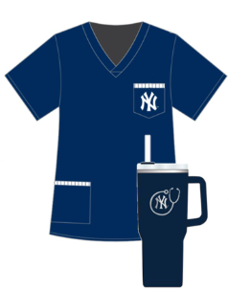

o

