Latieia Key
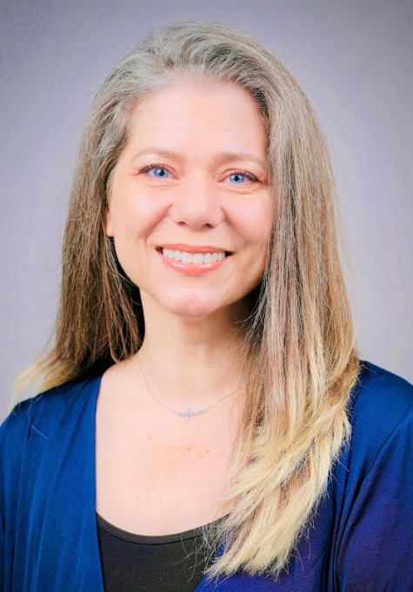
Passionate nurse leader focused on ensuring nurses have the knowledge and ability to engage in safe, effective, evidence-based nursing practice. Progressive solid nursing leadership experience committed to compassionate nurse development and professional nurse advocacy.
Degrees include a Doctor of Nursing Practice (completion in 2025), Post-Master Certificate in Education, Master of Science in Nursing, and Bachelor of Science in Nursing.
Currently working as the Director Enterprise Nursing Practice at Children’s Health. With experience in nursing experience, safety specialist, and accreditation to name a few.
Also multiple presentations including
- I Got Your Back: Keeping Patients and Ourselves Safe from Errors, Latieia Key and Lori Batchelor. Children’s Health Dallas, Nursing Grand Rounds. Nurses’ Week May 11, 2023.
- Alarm Fatigue, Latieia Key, Christina Smith, Sachin Shah, Olivia Hoffman. Children’s Health Nursing Grand Rounds, Dallas, TX 2022.
- PIV Infiltrations and Extravasations Improvement Beyond the Bedside, Latieia Key. Child Health Patient Safety Organization Safety Table, Virtual 2022.
- Recognition and Escalation in the Presence of Uncertainty, Latieia Key.Child Health Patient Safety Organization Safety Table, Virtual 2021
Awards and Recognitions
• DFW Great 100 Nurses (2024)
• Children’s Health Nurse Excellence: Systems Thinking Finalist (2014)
• D Magazine Nursing Excellence Award Finalist (2014)
• Texas Woman’s University Outstanding Student Leader (2003)
• Texas Nursing Student Association Image of Nursing Award (2002

