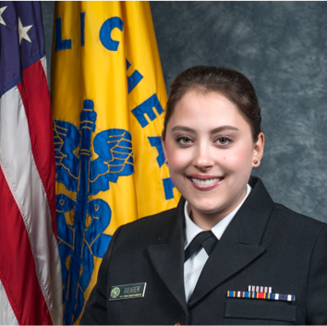

LT Monica Angelique Geiger, Regional Women’s Health Analyst, OASH Region 6 Dallas, TX

Monica joined the US Department of Health and Human Services in May, 2021 as the Women’s Health Analyst and is very excited to be convening partners, establishing networks and providing technical assistance to address the health and safety of women in Arkansas, Louisiana, New Mexico, Oklahoma, and Texas.

Monica commissioned as an officer in the United States Public Health Service through the Senior Commissioned Officer Student Training and Extern Program in 2015. Monica completed her BSN in Nursing from the University of Connecticut in 2016. She was then assigned to the Federal Bureau of Prisons, Department of Justice, where she worked as a staff nurse for 5 years. Monica is also an experienced American Heart Association BLS instructor. In 2020, she completed a Graduate Certificate in Nursing Education and a Master of Science in Nursing Leadership and Management, both from the George Washington University and in 2023 completed a Doctorate in Nursing Practice, Executive Leadership.

In her free time, she enjoys singing in the choir at the local church.  She hopes to bring to the office her passion for education, cultural experiences and, of course, some good Puerto Rican food.