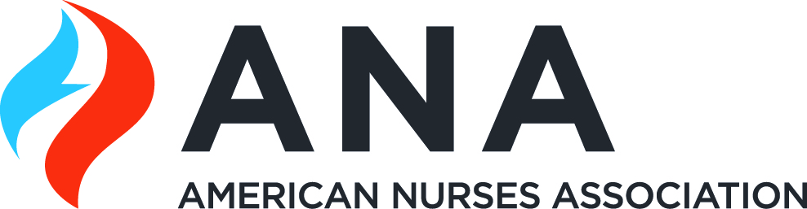 | 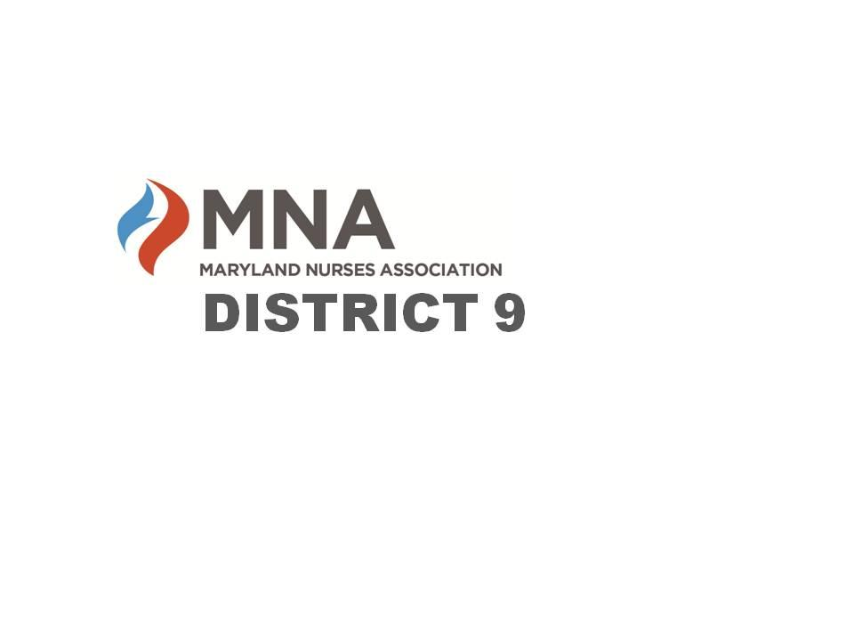

2024 MNA District 9 Annual Awards & Dinner Meeting Celebration

“Health in the 21st Century”
presented by:
Commander Nicki Conklin, RN, MPH
Nurse Officer in the United States Public Health Service Commissioned Corps
currently assigned to the US Food and Drug Administration
Office of Policy, Legislation, and International Affairs

Thursday, May 16, 2024
5:30pm – 8pm
The College of Southern Maryland Regional Hughesville Campus
6105 Foster Lane, Hughesville, MD 20637
Health & Sciences Room 106

Attendees can earn up to 1 contact hour from the Maryland Nurses Association (MNA) by participating in this event. The MNA is accredited as an approver of continuing nursing education by the American Nurses Credentialing Center’s Commission on Accreditation.
RSVP by Friday, May 10th
Cost: $35
payment options:
Venmo: @Kathleen-Miller-219 or Cash App: $mcapati 202-415-0143
(include email address and names of people registering in comments; please use family/friends setting)
Check to MNA District 9, send to Mariana Capati 4326 Shakespeare Circle White Plains, MD 20695
For more information including awards and scholarships,
visit our website or Facebook page
https://www.facebook.com/MNADistrict9 or https://mnadistrict9.nursingnetwork.com/

Need more information? Contact Kelly Gidwani, District 9 President Elect
kmgidwani@gmail.com

