 | 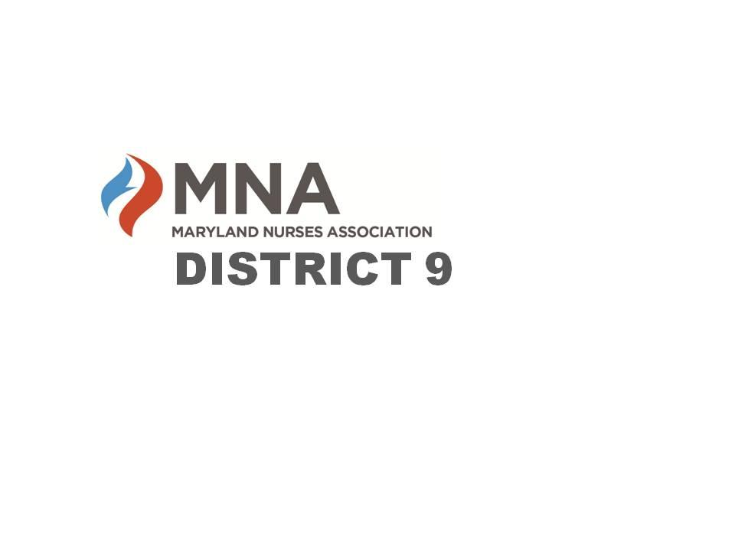
2024 MNA District 9 Scholarships

Maryland Nurses Association District 9 is seeking applications for their 2024
Nursing Awards which include two scholarship opportunities. Candidates must be a resident, employee, or student of District 9 (Calvert, Charles, St. Mary’s Counties). Applicants may only apply for one scholarship.

Deadline:
Applications must be submitted in their entirety no later than Sunday May 5th.

Awards will be presented at the MNA District 9 Annual Awards Dinner on Thursday May 16 at the CSM Hughesville Regional Campus.
Scholarship applicants are encouraged to attend. For more information, please go to https://www.facebook.com/MNADistrict9 or https://mnadistrict9.nursingnetwork.com/

Nominations for nursing awards are also being accepted at this time. For more information, please visit our website or Facebook page.

About the Scholarships Awarded by District 9: Grace E. Brown, RN, MS, FAAN was an active member of District 9 Nurses Association and a member of MNA Board of Directors for many years. Grace E. Brown was also a nurse educator and faculty member at the College of Southern Maryland. The following awards are presented in her memory by a special bequeath from the estate of Grace E. Brown. This year, each recipient will be awarded $1000.00 in scholarship assistance.

- The Grace E. Brown Scholarship, Basic Nursing Program (ADN or BSN) provides financial assistance to a student who is currently in nursing school in a basic program and has completed at least half of the required curriculum.

- The Grace E. Brown Scholarship, Advanced Degree Program (BSN, MSN, PhD, DNP) provides financial assistance to a licensed, practicing Registered Nurse who is currently enrolled to advance their degree.

Grace E. Brown Scholarship Application
Basic Nursing Program
(Awarded to an individual currently enrolled in an ADN or BSN program for their primary nursing degree)

Name of Applicant:

Address:

Phone:

Email:
Institution/Nursing Program:

Type of degree seeking:

Start date:

Expected completion date:

Are you a member of ANA/MNA?

To be considered for this award, the following documents must be submitted with this form before the deadline (see below):

- One letter of professional reference describing how the student’s direct nursing care and professionalism have made a positive impact on a patient, family, colleague, student, or community

- Statement from the applicant: describe what influenced your decision to enter in the nursing field and your career goals (1 page or less)

- Applicant’s current Resume’ (please include involvement in professional growth, community service, professional memberships, publications, continuing education, teaching/presentations, etc.)

- Tell us something about yourself that is not part of your essay

- Proof of enrollment in Nursing Program (unofficial transcripts)

Grace E. Brown Scholarship Application
Advanced Degree Program
(Awarded to a Registered Nurse advancing their degree)

Name of Applicant/Credentials:
Address:
Phone:
Email:
Place of employment:
Job title:
Number of years’ experience in nursing:
Area of current practice:
Institution/Nursing Program:
Type of degree seeking:
Start date:
Expected completion date:
Are you a member of ANA and MNA?

To be considered for this award, the following documents must be submitted with this form before the deadline (see below):

- One letter of professional reference describing how the person’s direct nursing care and professionalism have made a positive impact on a patient, family, colleague, student, or community

- Statement from the Applicant: describe what influenced your decision to enter in the nursing field, specific accomplishments, and your career goals (1 page or less)

- Applicant’s current Resume’ or C.V. (please include involvement in professional growth, community service, professional memberships, publications, continuing education, teaching/presentations, etc.)

- Tell us something about yourself that is not part of your essay

- Proof of enrollment in advanced nursing degree program (unofficial transcripts)

