Nigerian Nurses Association of North Carolina Scholarship
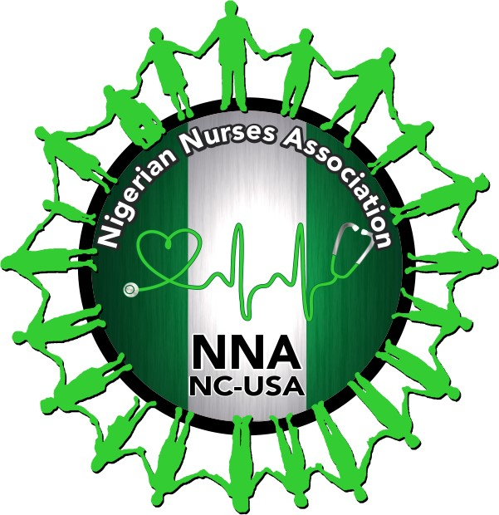

Purpose
NNANC is offering a one-time scholarship of $500 to 2 people per year to support quality nursing education in an accredited nursing school in the United States of America.
Criteria
- Nigerian Citizens only.
- Admitted in a pre-licensure nursing degree: ADN or BSN
- Admitting schools must be accredited by CCNE or ACEN.
- Parent(s) of an aspirant who is/are nurse(s), must be active member(s) of a chapter of NANNNA.
- Nursing prerequisite GPA: 3.5
- Completed general/prerequisite courses before applying.
- Submit admission letter to the nursing program.
- Submit a letter of intent/statement of purpose ( ≤ 500 words).
Deadline: 05/31/2024
Access to App. Form: https://nnanc.nursingnetwork.com/
Email Complete App Package to:
nnanc-scholarship-committee@googlegroups.com

