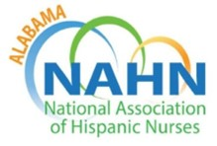

AGENDA
NAHN Alabama
Meeting April 25, 2024
6:00-7:00 p.m. CST
This meeting will only be conducted via zoom.
Join Zoom Meeting
https://uab.zoom.us/j/8374826905
Meeting ID: 837 482 6905
One tap mobile +13126266799,,

MEETING PURPOSE & GOALS
- Action on Routine Matters through consent agenda
  - Treasures Report
    - Current Balance: $29,204.97 (28,951.77)
      - Checking $1,969.09 (1,769.89)
      - Savings $ 6,572.74 (6552.56)
      - CDs $20, 663.14 (20,536.52)
        - MATURITY DATE 6/22/2024
        - MATURITY DATE 7/23/2024
    - Expenses: $1122.90
      - Storage Unit $36.90
_____________________________________________________________________________________
I. Call to Order
II. Consent Agenda
- Board Meeting Minutes of February 2024
- Treasurer report
III. President Update
- ALNAHN
  - Health clinic on February 3, 2024 from 11-4 pm at Holy Family Cristo Rey
  - Auburn Community event (Dr. Sarah Watts)
- Upcoming Volunteer opportunities
  - Children’s Hospital May 10, 2024 (volunteers needed)
  - UAB SON TBD
*We will be very active During National Nurses Week and Hispanic Heritage month- be
alert for calls to volunteer
- Upcoming Civic Engagement Opportunity (opportunity for students)
  - Voting
  - Find your legislator through this link https://myreps.datamade.us/

- Additional Leadership/Professional Development Opportunities
  - Climate health Webinar

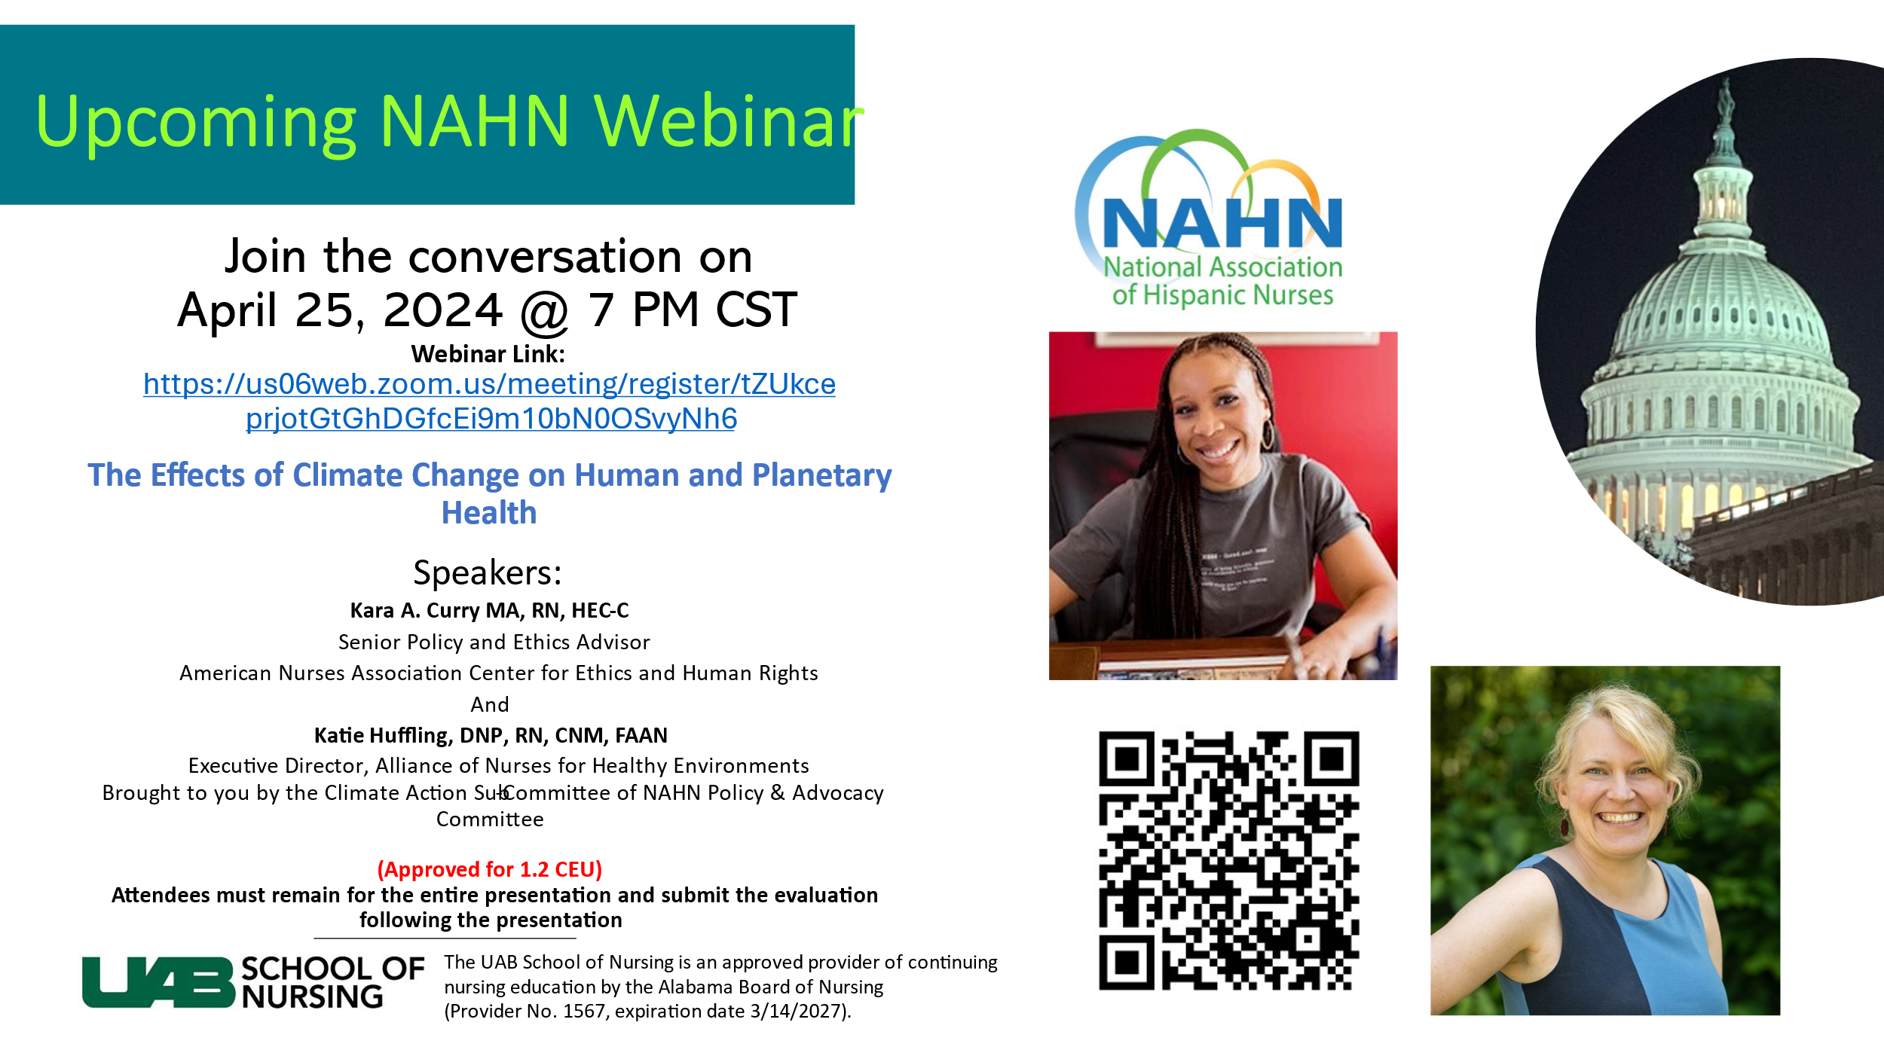Registration Link

- NATIONAL
  - Upcoming Elections May 31-June 7, 2024

  - National Conference (July 31-Aug 3) Atlanta, GA Agenda Link
  - Leadership Institute Wednesday, July 31 from 9am – 5pm
    - Chapter Leadership Discount for LLI
    - $80 off LLI registration ($119 instead of regular $199 rate)
  - Student cost- $250.00 (due by Jun 14^{th)}. (NAHN AL will cover hotel expenses)
Please let me know ASAP if you wish to attend
- Student registrants for the Annual Conference are expected to attend the student bootcamp on July 31 from 12-5pm EST

Policy: Please see the NAHN National Conference Student Sponsorship Policy for
Full requirements. Please review the policy for the student sponsorship so you
are aware of your role and expectations at the Annual Conference.

- The sponsorship opportunity is limited to those with an active student membership in NAHN (the code will only work if they have a student membership)

- The sponsorship is limited to the Annual Conference registration (July 31 – August 1). It does not include transportation, meal, lodging expenses, Latino Leadership Institute, or gala tickets.

IV. Items for discussion and action –
- Create and update profile on NAHN Alabama website

V. Round Table/Member sharing

Next Meeting will be June 27th, 2024- 6 -7 pm

Adjourn

