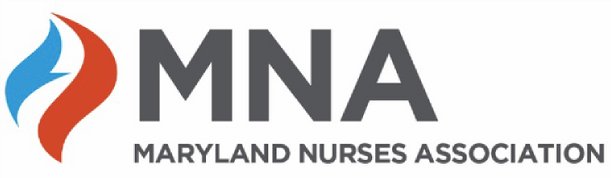**MNA Second Annual Gala**

Sunday, May 5, 5 PM

The Center Club, Baltimore

**One Evening…Many Stories. Celebrating Maryland Nurses!**

***Sponsorship Opportunities***

***Table Sponsors***

# Bronze Sponsorship: $3,000

One reserved table for ten quests; Logo and no more than 100 words in the gala program; and, Announcement of the sponsorship at the gala.

# Silver Sponsorship: $4,000

One reserved table for ten guests; Logo and no more than 100 words in the gala program;

Announcement of the sponsorship at the gala; and, Sponsorship noted in one monthly (March, April, and May) announcement sent via the MNA Nursing Network (list currently totals 11,104 including MNA members, nonmembers, and followers).

# Gold Sponsorship: $5,000

One reserved table for ten people; Logo and no more than 100 words in the gala program;

Announcement of sponsorship at the gala; Sponsorship noted in one monthly (March, April, and May) announcement sent via the MNA Nursing Network (list currently totals 11,104 including MNA members, nonmembers, and followers); and Opportunity to speak at the gala for no more than seven minutes.

***Product Sponsors***

***Step and Repeat Banner Sponsorship: $3,000*** *(Limited to one sponsor.)*

Company logo along with the MNA logo on the step and repeat banner. The banner is a popular location for guests to take photos that they share on social media.

***360 Degree Photo Sponsorship: $3,000*** *(Limited to one sponsor.)*

Company logo along with the MNA logo on the photos or product, if possible.

*The profit after expenses will be donated to the Nursing Foundation of Maryland.*

