**Nurse’s Night Out**

**April 30th, 2024**

Emergency Response Teams: Practice Makes Perfect

by:

Melissa Mark BSN, RN, CCRN & Danielle Wojtanowski MSN, RN, CCRN

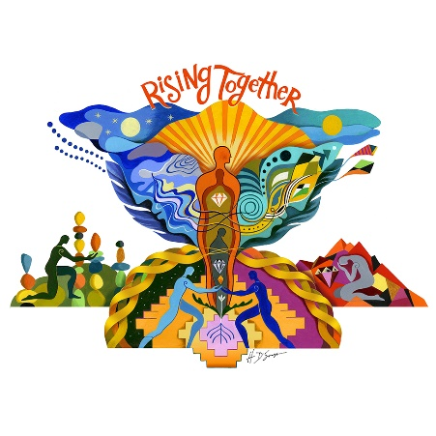Froedtert Hospital Rapid Response Team

Program:

5:15-5:30 p.m. Networking and Social Gathering

5:30 p.m. Presentation from Nasal Bridle Rep, Brian

AACN-GMAC Welcome and Announcements

6:00 p.m. **Complimentary Dinner**

6:30 p.m. Presentation by Melissa Mark and Danielle Wojtanowski

**This is a FREE event. All participants need to RSVP to** [**Milwaukeeaacn@gmail.com**](mailto:Milwaukeeaacn@gmail.com)**.**

Join us at The Alumni Club N88 W16718 Appleton Ave. Menomonee Falls, WI 53051

*Link for evaluation and CEs will be provided after the session.*

**Rising Together, We Will Lift Each Other Up!**