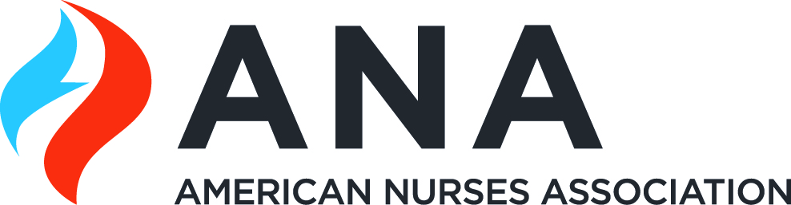 | 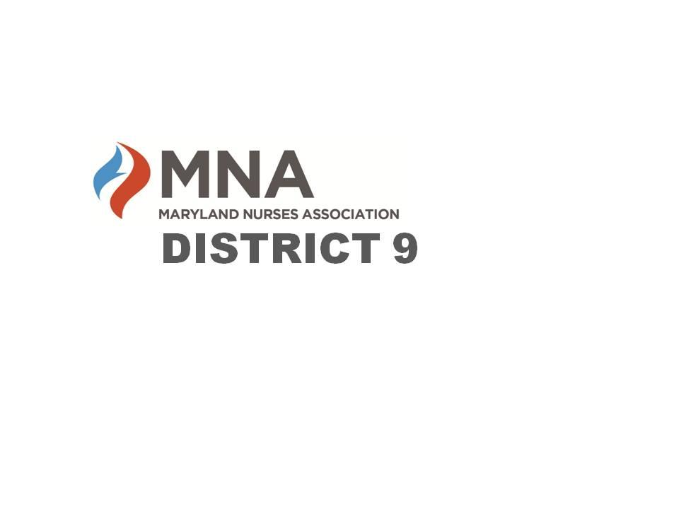
2024 Annual MNA District 9 Nursing Awards

The Maryland Nurses Association District 9 is seeking nominations for their 2024 Nursing Awards. Candidates must be a resident, employee, or student in District 9 (Calvert, Charles, and St. Mary’s Counties) and may only be considered for one award.
Deadline: Applications must be submitted in their entirety no later than Sunday May 5th.

Awards will be presented at the MNA District 9 Annual Awards Dinner on Thursday May 16, 2023, at the CSM Hughesville Regional Campus. Attendance is encouraged. For more information, visit our website or Facebook page (see below).

- The Nurse Educator Award is presented to an outstanding Registered Nurse whose primary focus is education. Nominees for this award may include nurses teaching in areas of staff development, community-based education, and schools of nursing.
- The Paula Luskus Heart of Service Award recognizes a Registered Nurse who is an outstanding member of our profession. Paula Luskus was well known as an inspirational leader who demonstrated a deep passion and dedication to the nursing profession. She was a strong advocate in the promotion of nursing and mentored many. Paula cared deeply for everyone she knew, and her generosity shined throughout her community. The recipient of this award must be well rounded, demonstrating perseverance and passion in the field of nursing and the community.
- The Nurse of the Year Award gives public recognition to an individual who demonstrates excellence in nursing. Licensed, practicing Registered Nurses in all fields of nursing are eligible.
Nursing Scholarships and Nursing Student of the Year Award will also be presented.
Contact us for more information or visit our website or Facebook page.
https://www.facebook.com/MNADistrict9 or https://mnadistrict9.nursingnetwork.com/

District 9 Nurse Educator Award

The District 9 Nurse Educator Award is presented to an outstanding nurse whose primary focus is education. Nominees for this award may include nurses teaching in areas of staff development, community-based education, and schools of nursing.

Candidate’s Name/Credentials:
Address:
Phone:
Email:
Place of employment:
Job title:
Area of practice:
Number of years’ experience in nursing:

Letter of Recommendation: Describe your association with the candidate and how as a nurse educator they have made a positive impact on a patient, family, colleague, or community. This may be through practice, community service, professional development activities, publications, continuing education, teaching, presentations, etc.

Your Name/Credentials:
Date:
Place of Employment:
Job Title:
Email Address:
Phone:

Paula Luskus Heart of Service Award

The Paula Luskus Heart of Service Award recognizes a Registered Nurse who is an outstanding member of our profession. Paula Luskus was well known as an inspirational leader who demonstrated a deep passion and dedication to the nursing profession. Paula was a member of the District 9 Board for many years making tremendous contributions to the organization. She was a strong advocate in the promotion of nursing and mentored many. Paula cared deeply for everyone she knew, and her generosity shined throughout her community. The recipient of this award must be well rounded, demonstrating perseverance and passion in the field of nursing and the community.

Name of Candidate/Credentials:
Address:
Phone:
Email:
Place of employment:
Job title:
Area of practice:
Number of years’ experience in nursing:

Letter of Recommendation: Describe your association with the candidate and how the nurse’s direct nursing care and professionalism have made a positive impact on a patient, family, colleague, or community. This may be through practice, community service, professional development activities, publications, continuing education, teaching, presentations, etc.
Your Name/Credentials:
Date:
Place of Employment:
Job Title:
Email Address:
Phone:
District 9 Nurse of the Year

The District 9 Nurse of the Year Award gives public recognition to an individual who demonstrates excellence in nursing. Licensed, practicing Registered Nurses in all fields of nursing are eligible.

Name of Candidate/Credentials:
Address:
Phone:
Email:
Place of employment:
Job title:
Area of practice:
Number of years’ experience in nursing:

Letter of Recommendation: Describe your association with the candidate and how the nurse’s direct nursing care and professionalism have made a positive impact on a patient, family, colleague, or community. This may be through practice, community service, professional development activities, publications, continuing education, teaching, presentations, etc.

Your Name/Credentials:
Date:
Place of Employment:
Job Title:
Email Address:
Phone:

