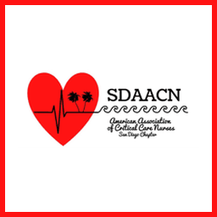
The San Diego AACN Chapter is sponsoring a $500 scholarship to attend NTI 2024 in Denver, CO
Celebrate 50 years of NTI
Denver May 20-22, 2024
Win scholarship assistance to attend
NTI in Denver! From San Diego AACN


Eligibility:  - SDAACN member (at least 3 months)  - AACN member  - Application essay of 500-1000 words  Payment of Scholarship funds:  - The maximum amount of the scholarship will be $500. This may be used to cover the cost of registration, airfare/travel and hotel expenses directly related to attending the conference.  - Proof of attendance and all receipts are required to receive reimbursement  Submit application to: scholarships@sdaacn.org  Include essay, AACN number, full name, address, email and phone number | Selection Criteria:  - Applicant will submit an essay addressing:  - The learning need of nurses in the Chapter/Community  - Description of how the NTI experience will facilitate their ability to address the learning need  - Desciption of a comprehensive plan for bringing their learning back to the chapter and community  - Note: Essay must be 500-1000 words  Submission and Selection timeline:  - Essay and application due April 15, 2024  - Applicants will be notified by May 6, 2024

