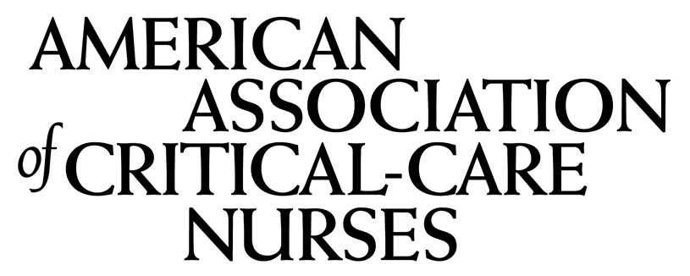

CE Program & Learning Evaluation Form

Participant Name:
Program Title: | The Organ Donation Process: Standards of Practice
Date: | February 29, 2024

To evaluate the effectiveness and quality of this program please supply the following information.

Use a rating scale of 1 to 3: where 1 = Agree; 2 = Neutral; and 3 = Disagree. For items that cannot be rated, indicate N/A

1. The program objectives were met. __________
2. The content adequately covered the learning objectives. __________
3. The program met or exceeded my expectations. __________
4. The information presented will enable me to be confident in making decisions about my practice __________
5. Attending this program has increased my level of knowledge on the Organ Donation Process. ___________
6. Major strengths and/or weaknesses of this program? ____________________________________________________
____________________________________________________________________________________________________________________________________________________________________________________________________
7. Suggestions to improve this program? _________________________________________________________________
____________________________________________________________________________________________________________________________________________________________________________________________________

8. Please rate each presenter using the rating scale above

Speaker (s) Name | Qualified | Knowledgeable | Organized | Effective
Annabel Henry, MSN, RN
Abraham Warshaw, MD

Participant Signature: __________________________________________________________

