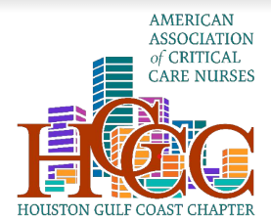
AACN Houston Gulf Coast Chapter invites you to an educational chapter meeting
Where: Season’s 52
842 W. Sam Houston Parkway, Houston TX 77024
When: August 1, 2024
Registration begins at 6:30pm, presentation at 7pm
Topic:
Tablo® Hemodialysis System in the Critical Care Setting
Sponsor: Outset Medical
Speaker: Lionel Bihm Jr., BSN, RN
Register on Nursing Network:
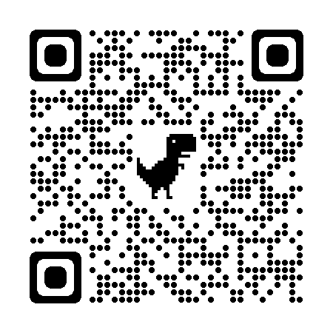
75 Seats available, so sign up soon to secure your spot!
We look forward to seeing you there!

