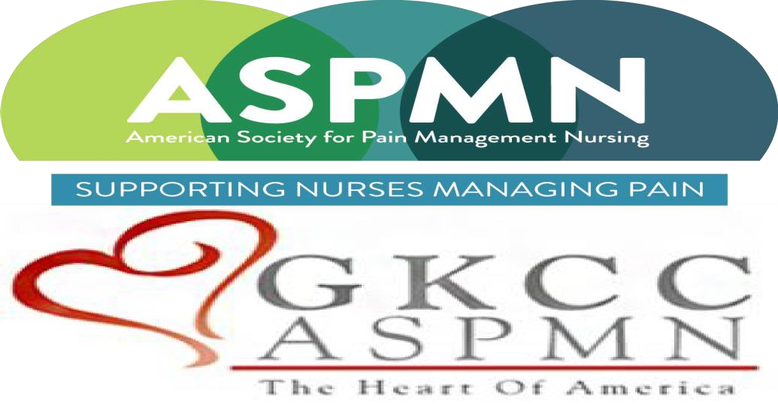  “Unlocking the Potential of Spinal Cord Stimulation in New Patient Populations”  Presented by  Zohra Hussaini, MSN, FNP-BC, MBA  With an unrestricted educational grant from NEVRO  Objectives:  - Review spinal cord stimulation patient selection and procedure overview.  - Understand mechanism of action and therapy versatility.  - Discuss services and support for better patient outcomes.  The Greater Kansas City Chapter of the American Society for Pain Management Nursing is approved as a provider of continuing nursing education by the Kansas State Board of Nursing. This course offering is approved for 1.2 contact hours applicable for RN, LPN, or LMHT relicensure. Kansas State Board of Nursing Provider Number: LT0279-0412GKCC-543. | March 14, 2024  6:00 PM  Season’s 52  340 Ward Parkway, KCMO 64112  This event is sponsored by NEVRO and has been approved for  1.2 CNEs.  Registration is required!  https://gkccaspmn.nursingnetwork.com  Zohra Hussaini, MSN, FNP-BC, MBA, is a board-certified family nurse practitioner specializing in pain management at the University of Kansas Health System, serving as the lead coordinator of APP's in the interventional pain clinic. She stays engaged in her profession serving on the board of her local chapter of the American Association of Nurse Practitioners (AANP) and participating in shared governance in her institution as a member of the Opioid Stewardship Committee and past-Chair of the Advanced Practice Provider Council. Zohra finds professional growth through active membership and participation at multiple national pain and nurse practitioner societies, serving as faculty, course director, and planning APP education. She is speaker and educator locally, nationally and internationally and is active in ongoing research and publications. Zohra also is an advisor to industry partners to advocate and promote APP educational opportunities.

