INW AANN chapter meeting Thursday, March 28 at 5pm
the Hive in Studio E.
The door code is 522477#
We will be discussing:
Plans for a local neuroscience conference (To be held on September 20, 2024).
Speakers, Vendors, Locations.

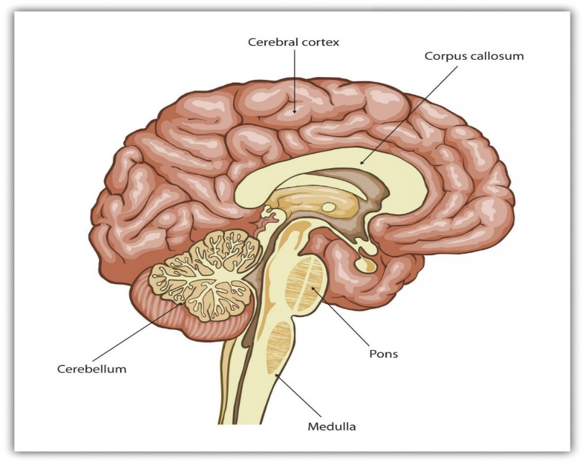
This Photo by Unknown Author is licensed under CC BY-SA-NC

