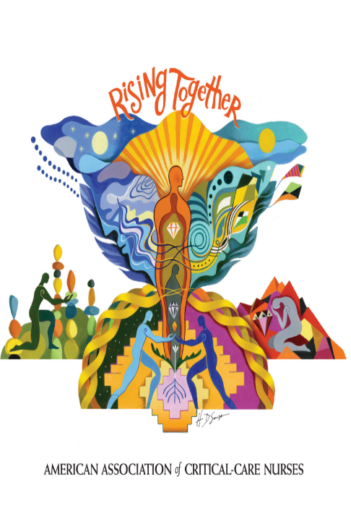

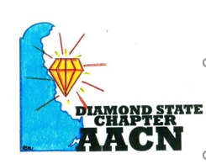
All applications are Due March 6, 2024
Eligibility
- Must be current AACN and Diamond State Chapter Member (can join day of application). DSC membership is $25 annually
- Answer 2 questions regarding your professional goals in attending NTI and how you will share and apply knowledge learned at NTI (each question max 300 words)
- Have not received a Diamond State Chapter NTI Scholarship in 2022 or 2023
- Is not a current Diamond State Board Member
Applicants will be notified by 4/3/2024 via email with the status of their application.

For additional information and/or how to join Diamond State Chapter,
Search Diamond State Chapter on Nursing Network or contact dennise_washington@bayhealth.org

Application QR code
Diamond State Chapter AACN NTI 2024 Registration Scholarships Available
You could be chosen to receive 1 of 2 scholarships for free registration and a travel credit to NTI in Denver.

