**Nurse’s Night Out**

**March 7th, 2024**

The Weight of Being a Surrogate Decision Maker: What Are They Really Carrying?

by:

Christine Restivo-Pritzl APNP, NP-C, ACHPN, Ruth Drazewski APNP, ACNS-BC, ACHPN, Whitney Gilbert LCSW, & Annie Friedrich PhD, HEC-C

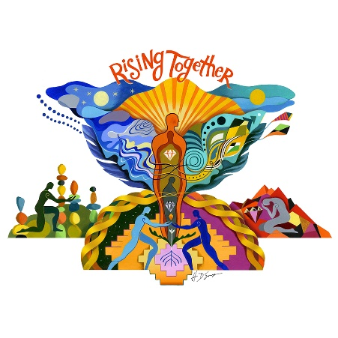Palliative Care Team

Program:

5:15-5:30 p.m. Networking and Social Gathering

5:30 p.m. AACN-GMAC Welcome and Announcements

5:35 p.m. **Complimentary Dinner**

6:00 p.m. Presentation by Palliative Care Team

**This is a FREE event. All participants need to RSVP to** [**Milwaukeeaacn@gmail.com**](mailto:Milwaukeeaacn@gmail.com)**.**

Join us at The Alumni Club N88 W16718 Appleton Ave. Menomonee Falls, WI 53051

*Link for evaluation and CEs will be provided after the session.*

**Rising Together, We Will Lift Each Other Up!**