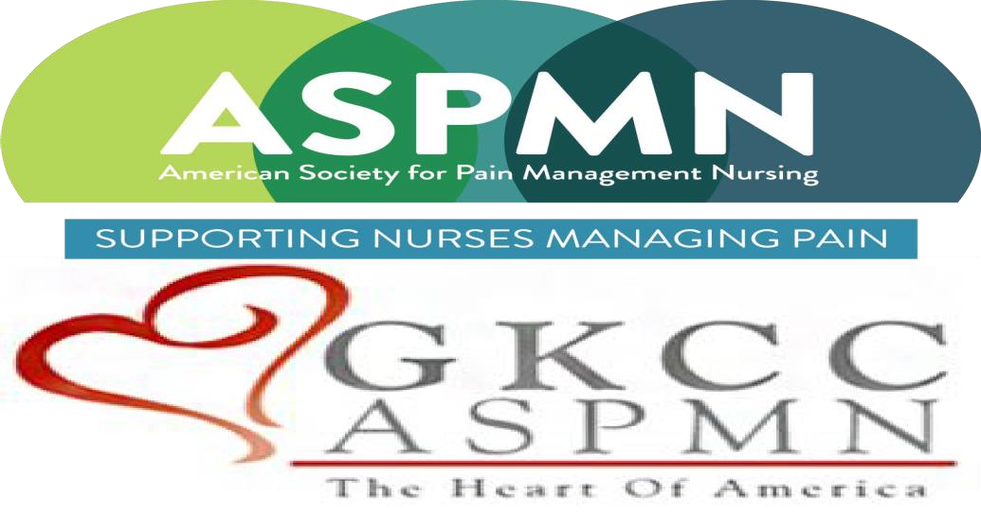  “Voxelotor for Patients with Sickle Cell Disease”  Presented by  Donna R. McCurry, ARNP, FNP–BC  With an unrestricted educational grant from Pfizer  Objectives:  - Review the pathophysiology of sickle cell disease (SCD).  - Understand how voxelotor works in the SCD cascade.  - Discuss the management of side effects and dosing of voxelotor.  - Review selected case studies.  The Greater Kansas City Chapter of the American Society for Pain Management Nursing is approved as a provider of continuing nursing education by the Kansas State Board of Nursing. This course offering is approved for 1.8 contact hours and 0.8 pharm contact hours applicable for RN, LPN, or LMHT relicensure. Kansas State Board of Nursing Provider Number: LT0279-0412GKCC-542. | Feb. 15, 2024  6:00-8:00 PM  Lidia’s  101 W 22nd St, KCMO 64108  This event is sponsored by Pfizer and has been approved for  1.5 CNEs and 0.8 Pharm CNEs.  Registration is required!  https://gkccaspmn.nursingnetwork.com  Donna McCurry, APRN, FNP-BC received her BS in nursing in 1980 and her MS in nursing 1n 1996 from the University of K S. She is an ANCC Certified Family Nurse Practitioner. Ms McCurry has extensive professional experience in home health, correctional nursing care, and as a diabetes educator. Since 2008, Donna has been providing specialty and primary care to individuals living with sickle cell disease at University Health, formerly Truman Medical Center. Sickle cell career accomplishments include development of a comprehensive SCD chronic care clinic. She is the site PI for both the Heartland/Southwest SC Network, and Johns Hopkins GRNDaD research study. She is the recipient of the Univ of KS Heart of HealthCare Award in 1993, TMC 2017 Hiersteiner Award, and 2018 March of Dimes Nurse of the Year Finalist as well as other awards. She is a board member and treasurer for Uriel E. Owens Sickle Cell Disease Association of the Midwest.  Her professional approach has been described as mostly low tech but very “high touch” with a demonstrated passion for facilitating individual wellness even while living with challenging, life altering health challenges.

