

**What’s Going On Upstairs?**

*Greater Fredericksburg Area Chapter of the*

*American Association of Critical Care Nurses Symposium*

**March 18, 2024**

**1500-2000**

Fick Center

Mary Washington Hospital Campus

**$40 – Includes dinner and CEU’s**

*Proceeds go towards nursing scholarships*

**Topics/Speakers**

-**How Stroke Centers Increase Quality of Community Health**

Susan Halpin MSN, RN

Stroke Coordinator, Mary Washington Healthcare

-**What the Hectomy That Needs a Thrombectomy?**

Dr. Omar Saeed, MD

Board Certified Vascular Neurologist – Mary Washington Healthcare

-**Under Pressure! …Diagnosis and Management of the High Intracranial Pressure State**

Dr. Sridhar Neralla, DO

Intensivist, Pulmonologist – Mary Washington Healthcare

-**From Provider to Survivor**

Greg Leitz, Retired Chief Paramedic with the Spotsylvania Volunteer Rescue Squad, Stroke Survivor

-**PCCN/CCRN Neuro Review with Focus on Subarachnoid Hemorrhage**

Mary Jane Bowles, DNP, RN, CCRN, CNS-BC

Clinical Nurse Specialist, New Grad Nursing Program – Mary Washington Healthcare

University of Mary Washington Nursing Faculty

Sign-up on: gfacaacn.nursingnetwork.com

Please invite your nursing friends and co-workers!

*Deadline to register is March 14th*

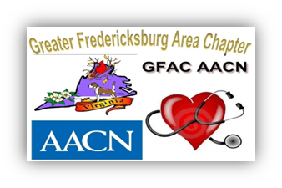

**AACN drives excellence in acute and critical care for nurses, patients and families.**