**Nurse’s Night Out**

**January 11th, 2024**

Thick and Thin of it: Anti-coagulants and other agents demystified

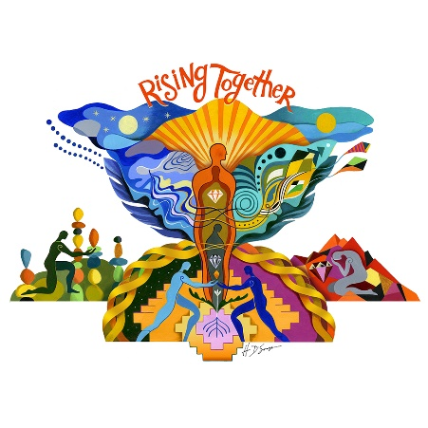by:

Ben Jung PharmD, MS, MPA

Pharmacist with Froedtert Health

Program:

5:15-5:40 p.m. Networking and Social Gathering

5:40 p.m. AACN-GMAC Welcome and Announcements

5:45 p.m. **Complimentary Dinner**

6:45 p.m. Presentation by Ben Jung PharmD, MS, MPA

**This is a FREE event. All participants need to RSVP to** [**Milwaukeeaacn@gmail.com**](mailto:Milwaukeeaacn@gmail.com)**.**

Join us at The Alumni Club N88 W16718 Appleton Ave. Menomonee Falls, WI 53051

*Link for evaluation and CEs will be provided after the session.*

**Rising Together, We Will Lift Each Other Up!**

This activity has been submitted to the American Association of Critical-Care Nurses for approval to award contact hours. The American Association of Critical-Care Nurses is accredited as an approver of nursing continuing professional development by the American Nurses Credentialing Center’s Commission on Accreditation.